Significant Contribution of WOTUS ephemeral streams to United States drainage networks

Craig B Brinkerhoff1,✉, Colin J Gleason1, Mathew J Kohen2, Doug Kysar3, and Peter A Raymond2

1 Department of Civil & Environmental Engineering, University of Massachusetts; Amherst, MA  
2 School of the Environment, Yale University; New Haven, CT  
3 Yale Law School, Yale University, New Haven; CT

✉ Correspondence: [Craig B Brinkerhoff <[cbrinkerhoff@umass.edu](mailto:cbrinkerhoff@umass.edu)>](mailto:cbrinkerhoff@umass.edu)

## One-Sentence Summary

Ephemeral streams are a fundamental component of drainage networks and directly implicate United States water quality.

## Abstract

Ephemeral streams flow only in direct response to precipitation and their regulation under the United States Clean Water Act (CWA) is currently contested (*1*). Despite the controversy, an understanding of ephemeral influence on drainage network hydrology has remained elusive. Here, we apply a geomorphic model for ephemeral streams to 20,708,880 distinct surface water features in the contiguous United States, finding that ephemeral streams contribute on average 3% of water to their drainage networks despite only flowing on average 37 days per year. Further, NA% of these ephemeral streams (on average) flow through cultivated/developed lands, illuminating a terrestrial-aquatic connection through which pollution may enter the perennial drainage network. We find that there is far-reaching potential for water quality degradation if CWA regulation is removed from American ephemeral streams.

## Main Text

Terrestrial drainage networks transport nutrients, sediments, pollutants, and other constituents from the land surface to the oceans (*2*–*5*), influencing all downstream water quality (*6*). The most upland component of drainage networks are ‘ephemeral’ streams, which flow only in direct response to precipitation and are disconnected from groundwater (unlike like larger rivers). Recently, the United States Navigable Waters Protection Rule (NWPR) proposed changes to what constitutes the ‘Waters of the United States’ (WOTUS), removing CWA jurisdiction from ephemeral streams (along with ‘disconnected wetlands’). The NWPR enables the destruction, filling in, and/or discharge of point-source pollution into the U.S. ephemeral stream network (*1*, **sullivan?**). The operational definition of WOTUS is a contentious topic and has received considerable attention from environmental groups, farm lobbying groups, and politicians since the CWA was enacted in 1972 (**Sullivan?**). The NWPR’s implementation is currently on hold as it sits before the U.S. Supreme Court.

Non-perennial streams (which include ephemeral and intermittently dry rivers) account for over 1/2 of the global river network (*7*). While much recent work has developed classification models for non-perennial streams (*7*–*11*), only one focused specifically on ephemeral streams (*11*) and all models stopped short of assessing their hydrological and biogeochemical contributions to their drainage networks. Thus, we presently can neither quantify the significance of ephemeral streams to watershed hydrology nor the potential water quality ramifications of the NWPR.

In that context, here we use a remarkably simple geomorphic model to identify ephemeral streams by comparing long-term water table depths to drainage network presence in 20,708,880 million discrete streams, rivers, lakes, reservoirs, canals, and ditches across the contiguous United States (CONUS). We perform a first-order survey of American ephemeral stream hydrology along three dimensions: 1) flow contribution/magnitude, 2) flow frequency, and 3) potential for point-source pollution (*12*). For 1) and 2), we use discharge, runoff and precipitation models and geomorphic scaling to quantify how often and how much ephemeral streams flow. For 3), we use land cover data to map riparian land uses for every CONUS ephemeral stream. Finally, we identify basins where all three dimensions coexist and significant water quality degradation will occur if the NWPR is enacted (*12*). We validate individual model components (Figs. S1-S4) and test parameter sensitivity when necessary (Figs. S5-S8) (*12*).

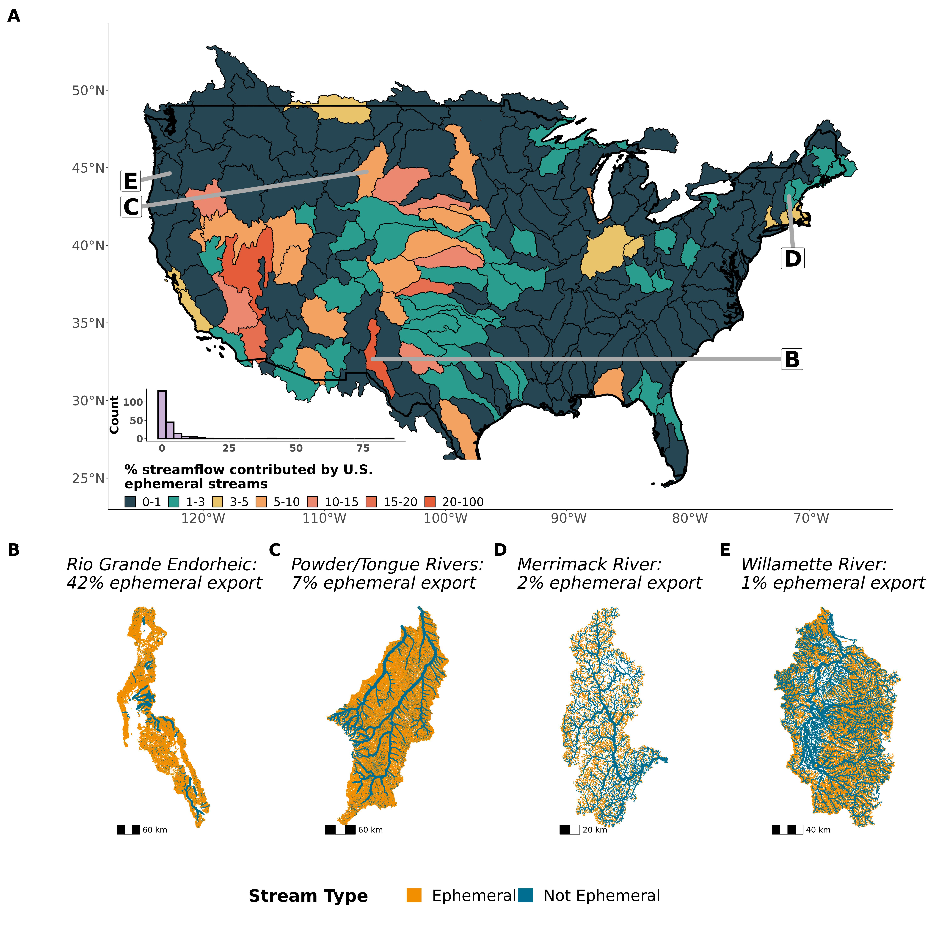

Fig. 1: Assessing ephemeral stream hydrology by the magnitude of their streamflow contribution. (A) Contiguous United States map and distribution of ephemeral streams’ relative contribution to streamflow, highlighting significant variability in the importance of ephemeral streams across the United States. (B-E) Drainage network maps (4 out of 205) for basins with a range of ephemeral streamflow contributions. Reach size corresponds to logarithmic bins of streamflow and are relative to map scale.

On average, ephemeral streams contribute 3% of all streamflow exported from drainage networks, with significant regional variability (Fig. 1a) controlled by geomorphic and hydrologic properties. Basins with an ephemeral streamflow contribution > 1% are generally in arid/semi-arid regions. Drainage networks in the Great Basin and Great Plains source an average of 5% of streamflow from ephemeral streams, with 6 drainage networks over 10% (mostly endorheic desert basins). The maximum ephemeral contribution is 85% for the central Nevada desert. In the East, ephemeral streams contribute less to streamflow (Fig 1a), with an average contribution of only 1%. The ephemeral portions of the drainage networks dominate total network extents and are relatively constant across a wide range of climates and topographies, but their streamflow contributions vary significantly (Fig. 1b-e).

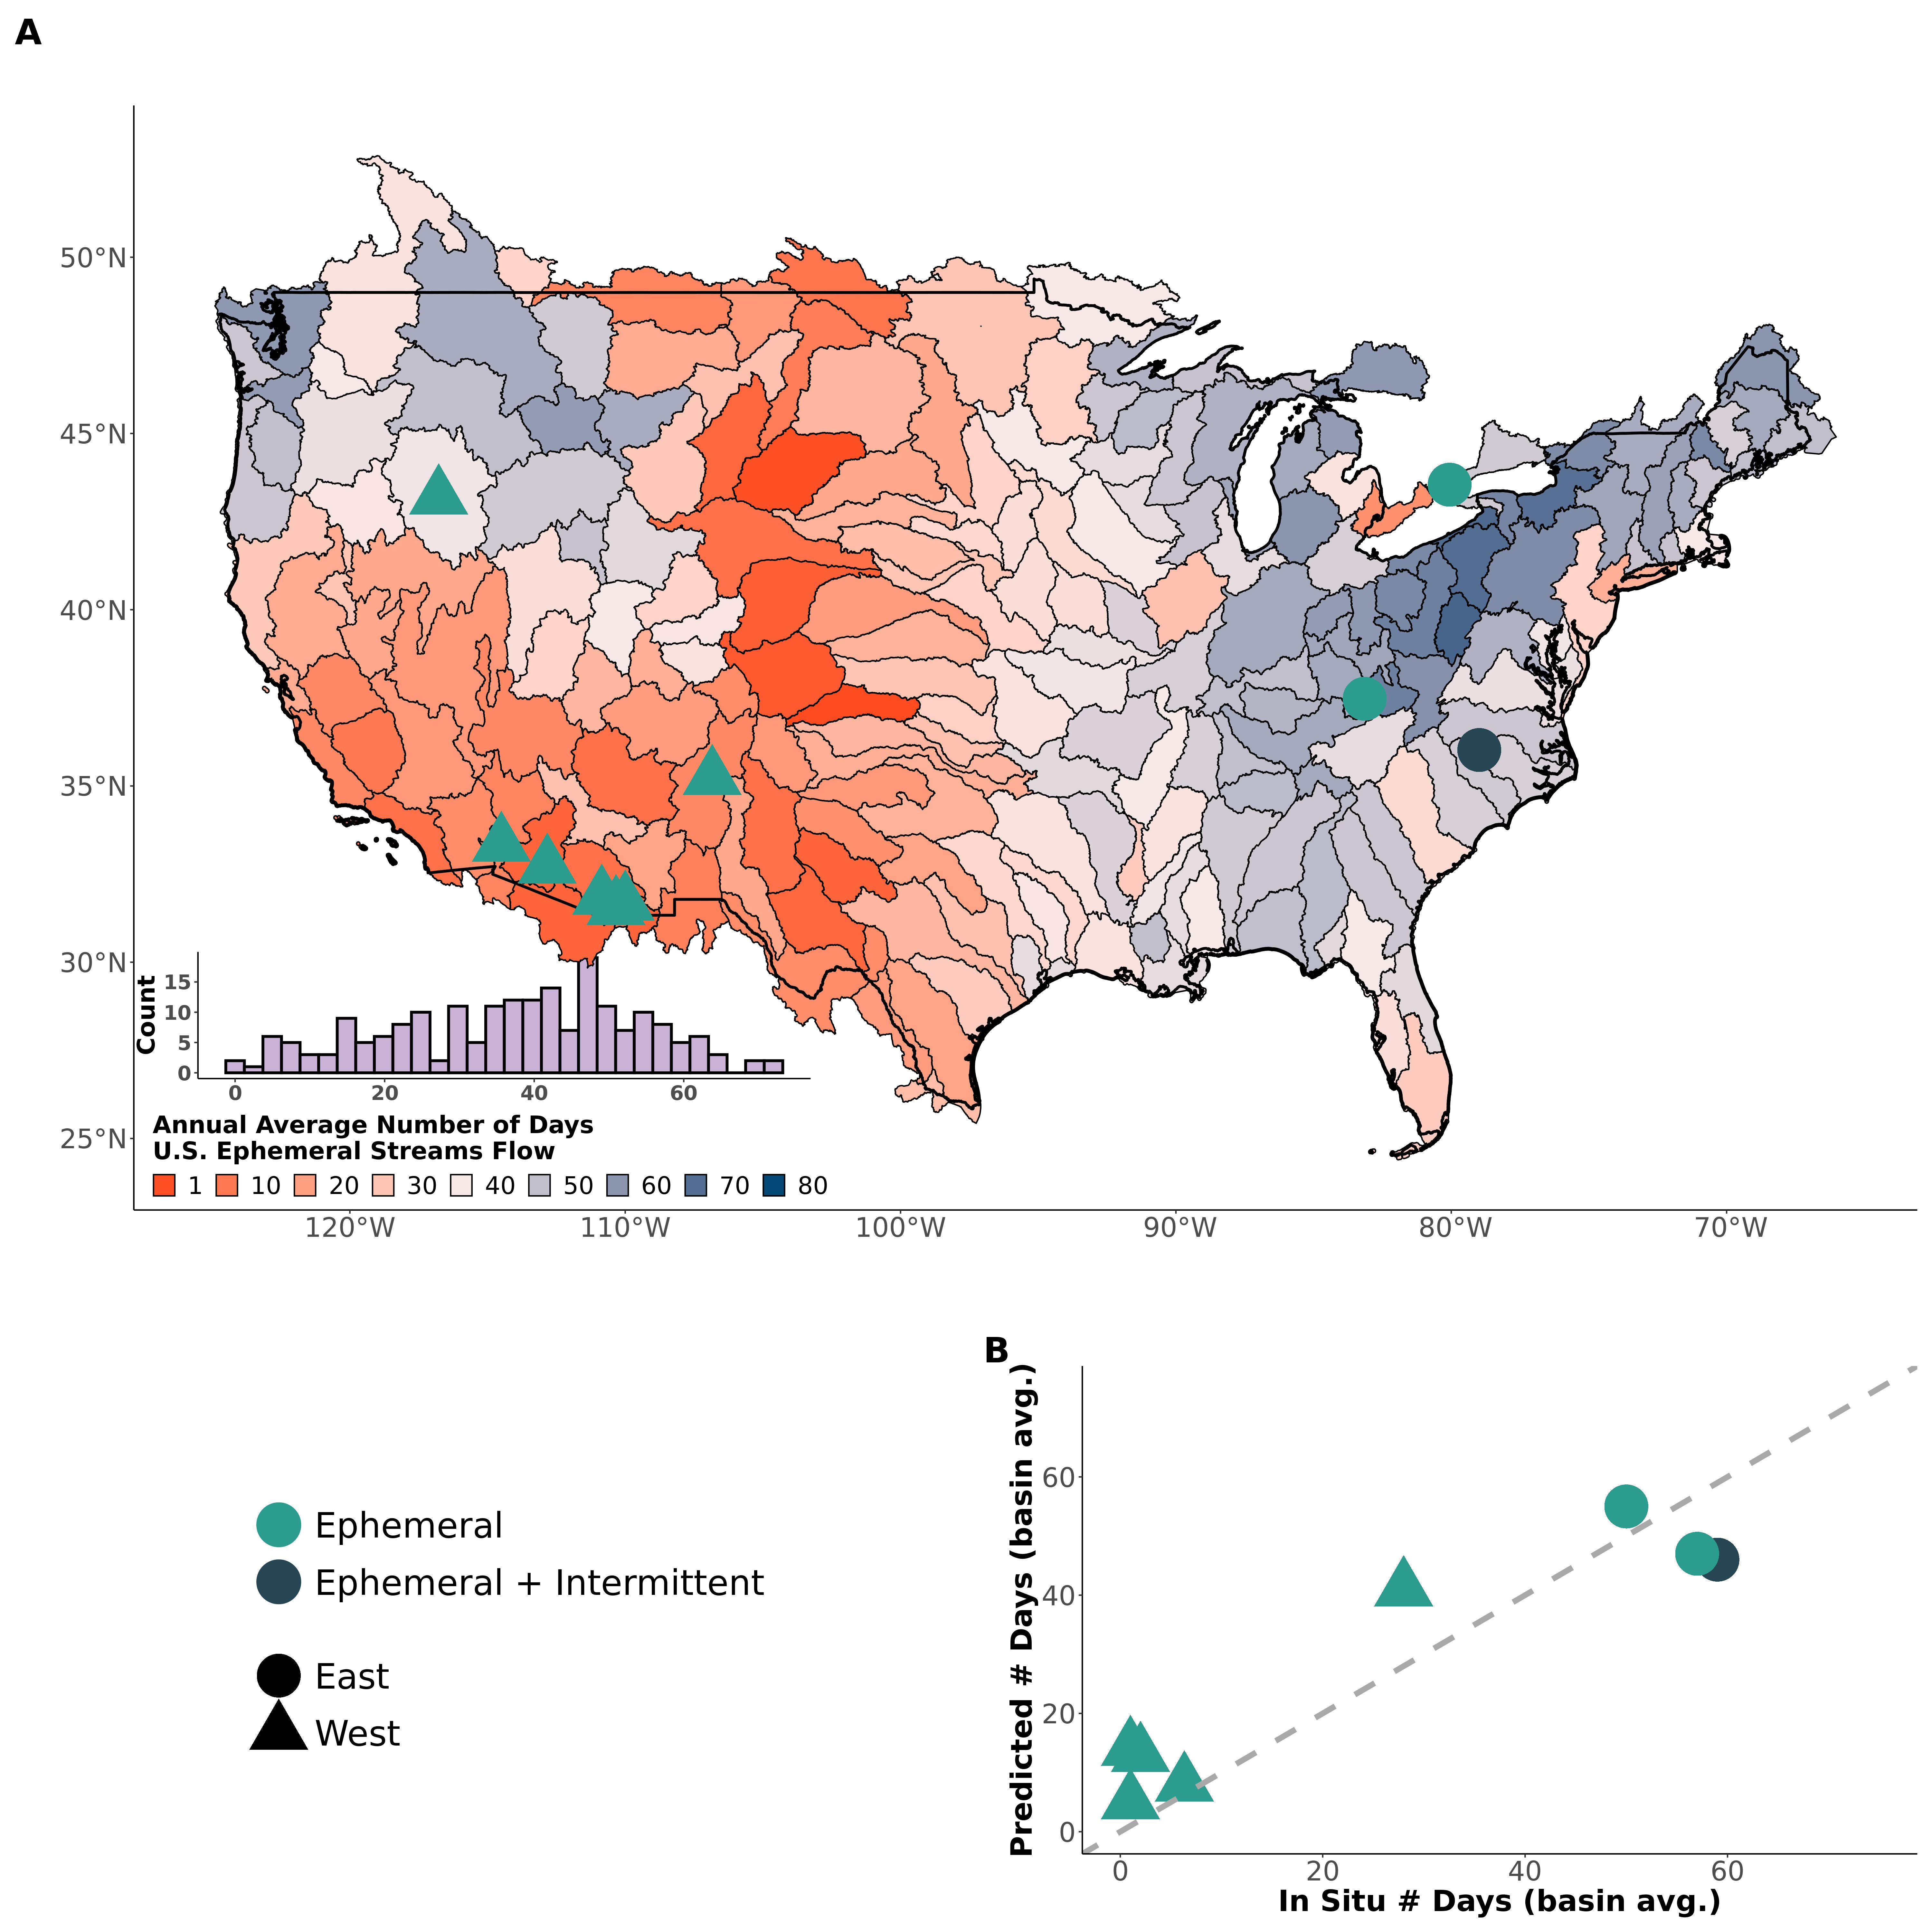

Fig. 2: Assessing ephemeral stream hydrology by their flow frequency. (A) Contiguous United States map and distribution of the average number of days that ephemeral streams flow per year (for 1980-2010), with points indicating approximate locations of field data. (B) Verification of model results with field data. The dark green point corresponds to a catchment that transitions from intermittent to ephemeral.

The significance of the ephemeral contribution to streamflow (Fig. 1a) is underpinned by how infrequently they flow (Fig. 2a). Ephemeral streams flow no more than 72 days in an average year, with a mean of 37 days. Ephemeral flow frequency is normally distributed and largely follows topographic and climatic patterns: ephemeral streams in the Great Plains and Great Basin only flow 27 days a year on average, while they flow 48 days on average in eastern Basins. In the southwest deserts, this drops to an average of 14 days a year. Overall, 4 ephemeral networks flow less than 5 days a year on average. These results manifest from a delicate balance between hydro-climatic properties (where rainfall frequency, rainfall magnitude, and runoff efficiency control the size and occurrence of runoff events) and geomorphology (where catchment size controls the amount of accumulated runoff needed to produce streamflow) (*12*). The simple, completely uncalibrated model uses only a precipitation model, runoff data, and geomorphology scaling theory, yet it reasonably matches independent field measurements of catchment-averaged, ephemeral flow frequency (Fig. 2b) (*12*). Given how infrequently they flow, the ephemeral contribution to streamflow becomes dramatically larger under the assumption that all ephemeral streams are simultaneously flowing (Fig. S9).

Overall, our results (Figs. 1, 2, S9) suggest a terrestrial-aquatic connection that facilitates point-source pollution to enter the CONUS drainage network if ephemeral streams are flowing. While there is no guarantee that there will be pollution discharged into one of any one ephemeral stream, in general cultivated and/or developed lands are associated with the potential for point-source pollution via farms, manufacturing facilities, concentrated animal feed operations (CAFOs), sand and gravel operations, and other similar activities. On average, NA% of a drainage network (by length) is ephemeral and flows through cultivated and/or developed lands, with the greatest influence of cultivated/developed lands being throughout the Midwest and Great Plains (Fig. 3). Because this assessment cannot be performed on the smallest stream order in our model (*12*), Fig. 3 represents an extremely conservative lower bound and the true fraction of cultivated/developed ephemeral streams is much larger.

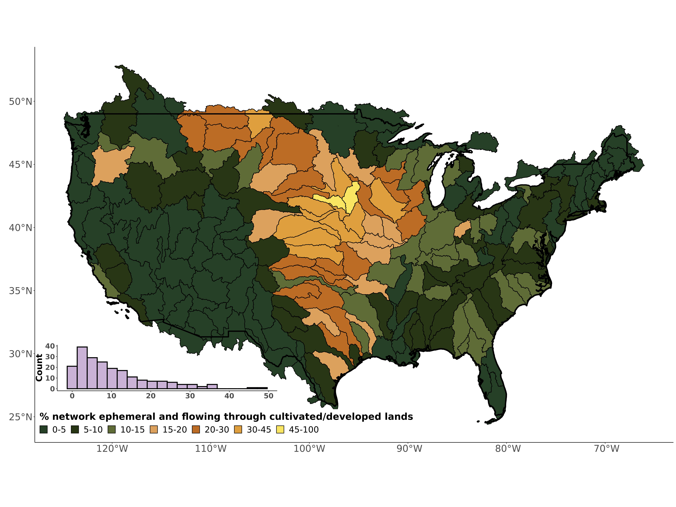

Fig. 3: Assessing ephemeral stream hydrology by their potential for point-source pollution. Contiguous United States map and distribution of the percent of ephemeral streams that flow through cultivated and/or developed riparian landscapes. Because this assessment cannot be performed on the smallest stream order in our model (*12*), this represents an extremely conservative lower bound and the true fraction of cultivated/developed ephemeral streams is much larger.

Finally, we assess all three dimensions of the ephemeral contribution to drainage networks. The Great Plains and desert endorheic basins are particularly at risk for water quality degradation via ephemeral streams and the NWPR (Fig. 4). The other desert basins throughout the midwest are at the lowest risk (Fig. 4) due to infrequently flow and little to no cultivation/development along ephemeral streams

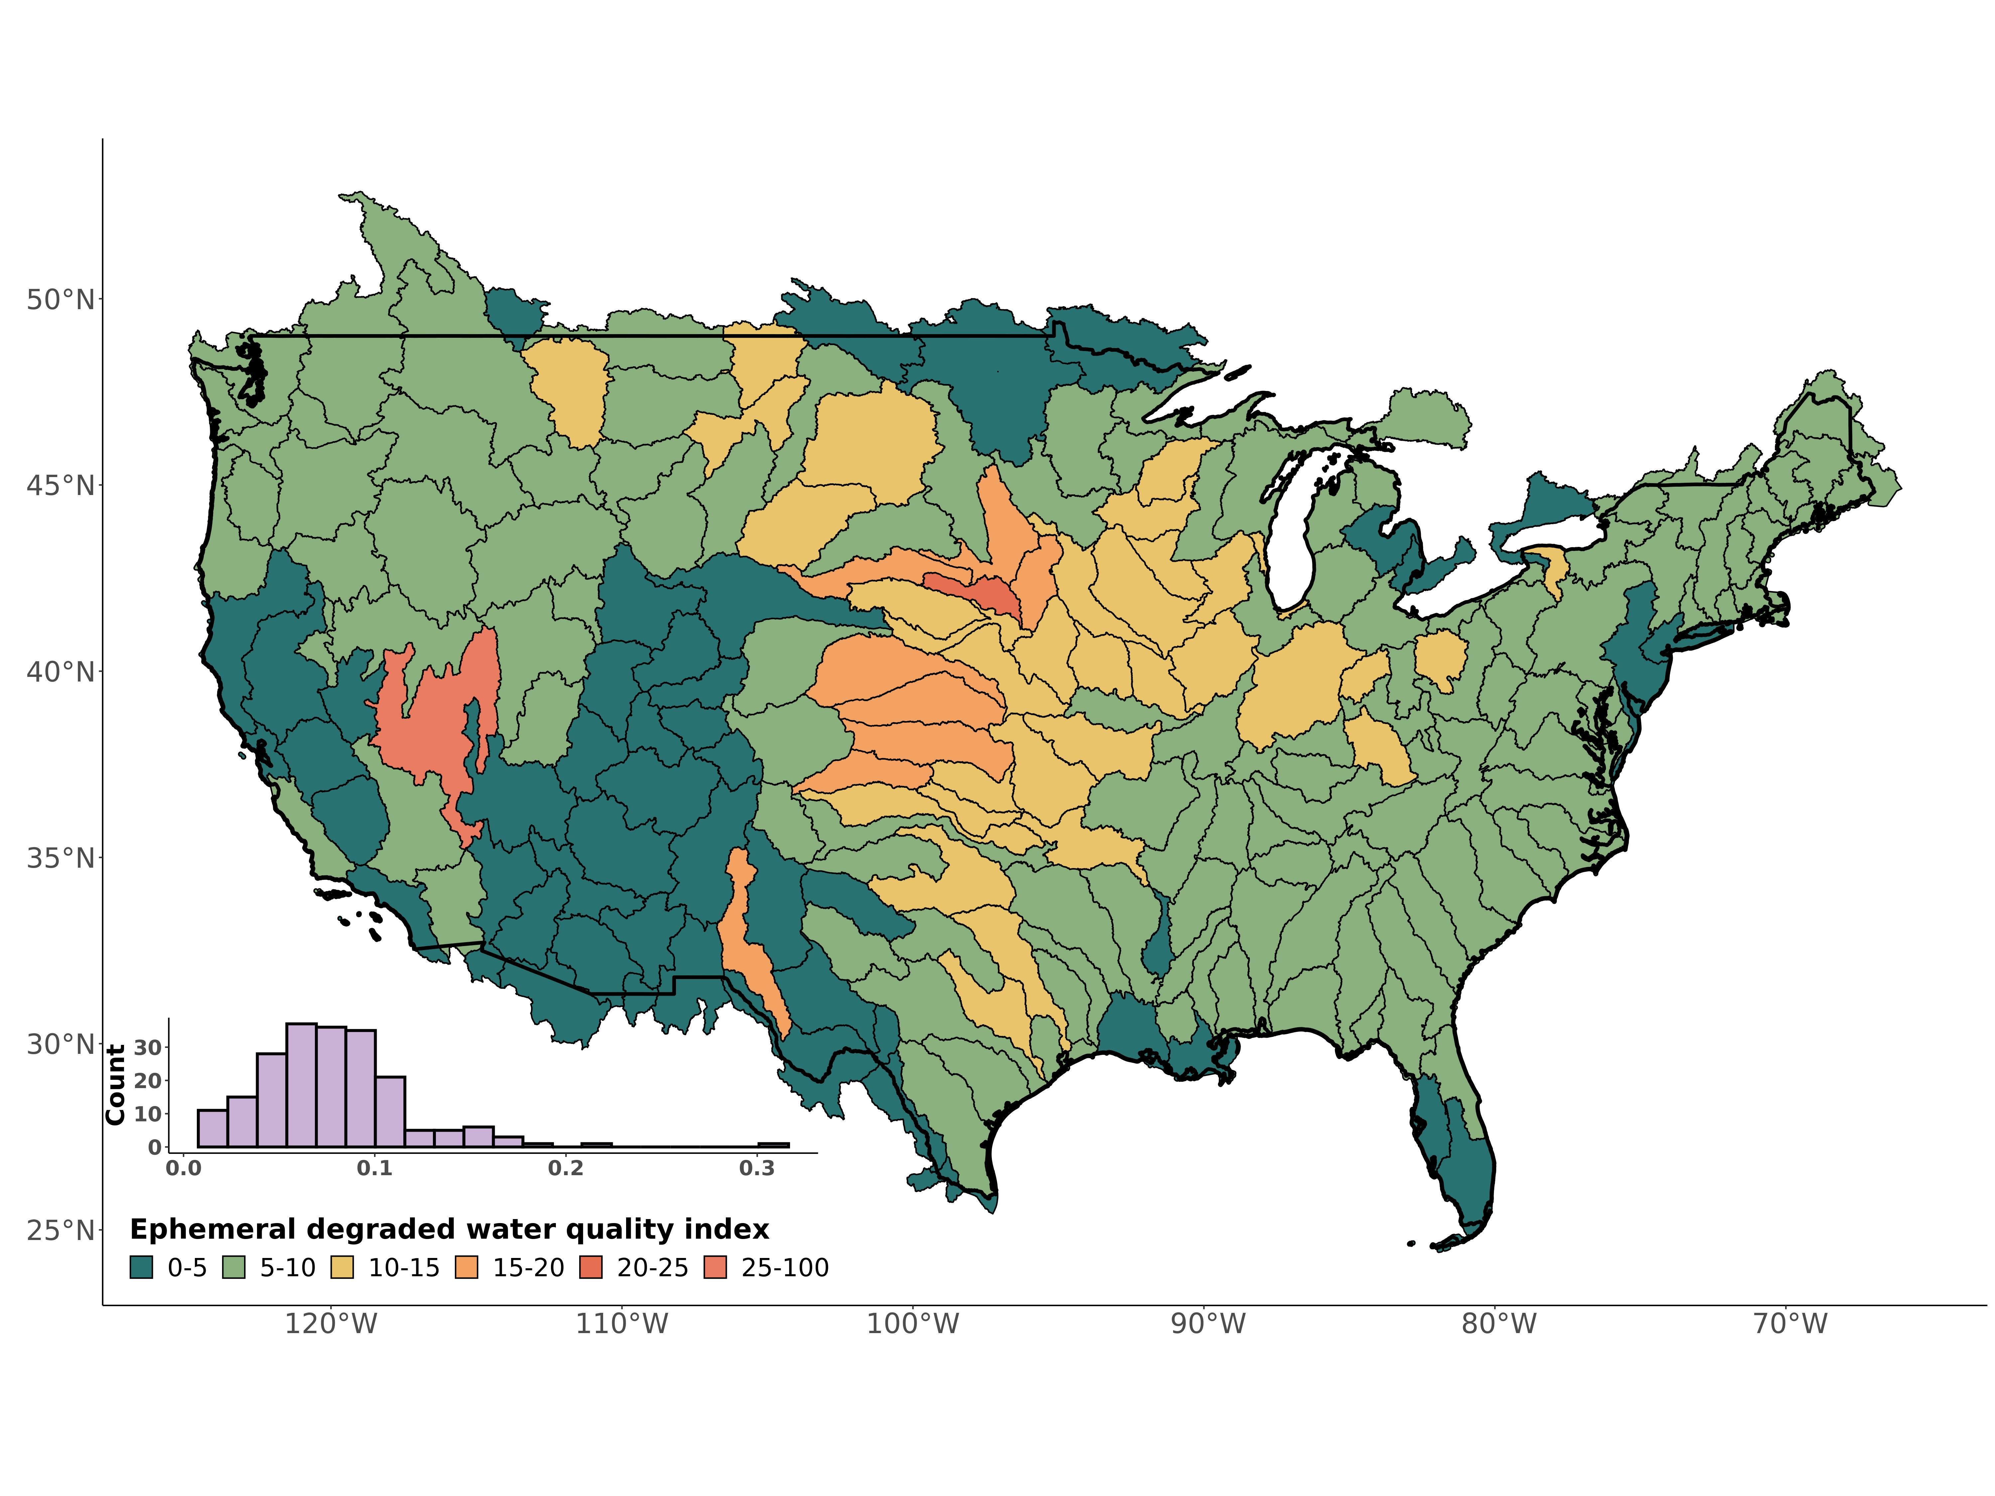

Fig. 4: (A) Bivariate map of the ephemeral streamflow contribution (blues) versus the fraction of ephemeral streams flowing through cultivated/developed riparian lands (reds). Bins for the latter axis are the distribution’s tertiles. The dark purple basins, where both values are high, suggest the greatest potential for water quality degradation due via the NWPR. (B) An example drainage network discerning cultivated/developed ephemeral steams for the Republican River Basin in the central Great Plains. Reach size corresponds to logarithmic bins of streamflow and is relative to map scale.

**Room for 1 policy paragraph here** With significant groundwater pumping in the central Great Plains, it is likely that these basins significance as river channels become increasingly disconnected from groundwater and ‘turn ephemeral’ (*13*, *14*).

When compared against the ephemeral contribution to streamflow, four distinct regions emerge (Fig. 4): desert basins where ephemeral streams contribute much streamflow but are rarely developed/cultivated (blue in Fig. 4a), eastern basins where ephemeral streams contribute little streamflow but are extensively developed/cultivated (reds in Fig. 4a), western basins where ephemeral streams contribute little streamflow and are rarely developed/cultivated (whites in Fig. 4a), and the transitional region where both co-exist (purples in Fig. 4a). This final region, comprising much of the Great Plains, is most at-risk for potential water quality degradation due to the NWPR, where high pollution potential co-exists with a significant ephemeral influence on drainage network hydrology.

## References

references bust be moved here manually

## Acknowledgements

We thank Dr. Ying Fan Reinfelder, the USGS, and the EPA for making their data and/or models freely available. This study was made by possible by the Unity cluster at the Massachusetts Green High Performance Computing Center (MGHPCC), where all modeling was performed.

## Funding

Craig Brinkerhoff, Peter Raymond, and Colin Gleason were supported by *WROL*. Craig Brinkerhoff was also supported by *FINESST*.

## Author Contributions

* Conceptualization: PAR, CBB, MJK, DK
* Methodology: CBB, PAR, CJG
* Investigation: CBB, PAR, MJK, DK, CJG
* Visualization: CBB
* Supervision: PAR
* Writing- original draft: CBB
* Writing- review & editing: CBB, CJG, PAR, MJK, DK

## Competing interests

Authors declare that they have no competing interests.

## Data and materials availability

All input data and/or models are available in the main text or the supplementary materials. The ephemeral classification results, per drainage reach, are archived at ____________.

## Supplementary Materials

* Materials and Methods
* Figs. S1 to S7
* Tables S1 to S3
* References (##–##)

## This PDF file includes:

* Materials and Methods
* Figs. S1 to S8
* Tables S1 to S3

## Materials and Methods

To identify WOTUS (Waters of the United States) ephemeral streams throughout the contiguous United States (CONUS), we use a global soil hydrology model (*15*), high-resolution drainage network hydrography (*16*), and hydraulic geometry/drainage network scaling theory (*17*–*19*). To model basin-scale estimates of the mean annual ‘number of days flowing’ for ephemeral streams, we used long-term records of runoff and precipitation for each basin (*20*, *21*), as well as previous fieldwork on headwater hydromorphology (*22*). To identify basins most ‘at-risk’ for point source pollution in ephemeral streams we use the USGS National Land Cover Dataset for 2019 (*23*).

All modeling and analysis was performed on the Unity Cluster at the Massachusetts Green High Performance Computing Center using publicly available datasets, models, and entirely free and open-source geoprocessing tools in the R programming language.

### 1 Drainage network framework

#### 1.1 Overview

CONUS drainage network hydrography is defined by the United States Geological Survey (USGS) National Hydrography Dataset High-Resolution (NHD-HR) built at 1:24,000 map scale (*16*). This is updated and higher-resolution version of the commonly used National Hydrography Dataset and is still in development by the USGS. We use the data publicly available as of Spring 2022. This is the highest resolution hydrography data available and is often treated as a gold-standard to benchmark hydrography models against. The NHD-HR is discretized into ‘reaches’, which correspond to mass-conserved segments of rivers, streams, ditches, canals, lakes, and reservoirs. The NHD-HR uses artificial flowpaths to maintain network topology through lakes and reservoirs, and here we use a previous framework to incorporate discretized lake/reservoir bathymetry into our model that accounts for complex lake/reservoirs with multiple river inputs (*24*). The NHD-HR also uses nested drainage basins across 12 scales. We run our model at the 4th level (Figs. 1,3,4), and our mapping validation at the 2nd level (Fig. 2). This was done based on data resolution, data availability across the United States, and ease of interpretation.

As will all human-built products, NHD-HR data quality varies across CONUS. We identified significantly higher drainage densities in the NHD-HR for the state of Indiana (often 1-2x the stream orders as other portions of a given basin in adjacent U.S. states). For these basins, we manually removed the lowest 1 or two stream orders within the Indiana portions of these basins, until the whole-basin drainage density was visually consistent. We also removed all divergent reaches, i.e. minor flowpaths that diverge from the main downstream path of flow. We did not remove the rest of the flowpath downstream of a divergent reach if there was another, non-divergent source that joined and made the path no longer divergent. Divergent channels are generally alternative flowpaths for the same rivers, and so we remove them to avoid double-counting reaches in the same, multi-channel river.

#### 1.2 Discharge model

Each reach is associated with a mean annual discharge $\overset{‾}{Q}$ as modeled by the USGS (*16*). These are obtained through a runoff routing scheme that additionally accounts for evapotranspirative losses (i.e. losing streams) and is ‘gauge-adjusted’ at sites with streamgauges to improve accuracy. The USGS validated this model using mean annual streamflow for 1970-2000. To confirm model performance for more recent years, we extend the validation to 1970-2018 using all USGS streamguages with sufficient data (Fig. S2). The discharge model is adjusted at gauged reaches to match observed conditions but the unadjusted values are also publicly available, enabling a validation of both the gauged and the ungauged discharges to get a complete picture of model error. Both are presented in Fig. S2. There is strong agreement with the gauges, with the model strongly capturing mean annual discharges for 1970-2018 in both gauged and ungauged settings.

We also calculate a hypothetical ‘mean annual flowing discharge’ ($\overset{‾}{Q_{f}}$) to assess ephemeral influence if all ephemeral streams in a basin are flowing at once (Fig. S8). To do this, we use the theory laid out in equations S1-S3, where $Q_{d}$ is the mean daily discharge, and $N_{flw}$ is the mean annual number of ephemeral flowing days per year. Equation S3 reduces our unknowns to just $N_{flw}$, whose calculation is described in Ssection 6.

$$\overset{‾}{Q}=\frac{\sum_{1}^{365}{Q_{d}}}{365}\left(S1\right)$$

$$\overset{‾}{Q_{f}}=\frac{\sum_{1}^{365}{Q_{d}}}{N_{flw}}\left(S2\right)$$

$$\overset{‾}{Q_{f}}=\overset{‾}{Q}*\frac{365}{N_{flw}}\left(S3\right)$$

#### 1.3 Hydraulic Geometry

We use hydraulic geometry scaling to obtain broad estimates of mean annual river, lake, and reservoir depth that are needed to assess ephemerality (Section 3). For rivers, canals, and ditches we used the relation from (*18*), who fit an equation of the form $H=c{\overset{‾}{Q}}^{f}$ on over 500,000 USGS in situ measurements of river channel depth *H* and discharge *Q*. For lakes and reservoirs, we mass-conservation to obtain average depths from lake/reservoir volume (*Vol*) and surface area *SA*. *Vol* was scaled using an existing equation of the form $Vol=a{\left(SA\right)}^{1.2}$ (*17*), developed using the Hurst coefficient for self-affine surfaces and existing datasets.

### 2 Field data on stream ephemerality

We use a dataset of field assessments of ‘stream ephemerality’ to validate our stream classification model. The dataset is also used to inform the Hortonian scaling that captures the full distribution of ephemeral streams (Section 4). This dataset comes from three sources: a) EPA WOTUS jurisdictional determinations, b) USGS streamgauges, and c) field assessments of New England streams. These are described next.

The EPA Jurisdictional Determinations dataset (*25*) consists of site assessments (as of 06/20/2022 when downloaded) for WOTUS status made at the landowners request, where status was determined under the at-the-time WOTUS definitions. We filter this dataset to include only determinations made under the NWPR after it was enacted in 2020, which includes an explicit category for ephemeral streams to exclude them from WOTUS. This amounts to over 60,000 distinct jurisdictional determinations (including multiple determinations in the same reach, over space and time) and forms the bulk of our dataset. To make the dataset copacetic with our model, we remove data not associated with surface water features directly connected to the drainage network: adjacent/riparian wetlands, drylands, uplands, upland or non-adjacent wetlands/ponds/depressions, croplands, wastewater plants, and groundwater. We retained all other determinations that are directly connected to the drainage network (rivers, lakes, reservoirs, canals, ditches, stormwater control features, and artificial surface water features) and recast all determinations as ephemeral or non-ephemeral.

We supplement the Jurisdictional Determinations dataset with the USGS streamgauge network. Because the EPA Jurisdictional Determinations are done on a voluntary basis at the landowner’s request, it is biased towards surface waters whose WOTUS status is difficult to determine without a propser field assessment and thus rarely includes larger (usually perennial) rivers. To make sure we are also correctly classifying these rivers, we use gauged rivers (section 1.2). All gauged rivers that, on average, are flowing 95% of the year (for 1970-2018) are assumed to be non-ephemeral, and are added to the dataset as such.

Finally, we assess stream ephemerality in the northeastern U.S. ourselves as our filtered and cleaned dataset includes no ephemeral reaches in this region. We follow the ‘expert protocol’ used by North Carolina’s department of Water Quality for assessing stream ephemerality (*26*). This protocol uses geomorphic, hydrological, and biotic indicators of seasonally and/or permanently high water tables to assess stream permanence. We use our local knowledge to identify streams we thought are likely to be ephemeral, verify they are present in the hydrography (but do not look at the model result a priori to avoid biasing our assessments) and assess the channels following the protocol. Classification results are in Table S1 for five sites. All streams are assessed over 48 hours from the most recent rain event to avoid the influence of delayed runoff in the channel that might be mistaken for baseflow. Note that we do not perform full soil assessments nor species counts as the protocol technically specifies, but instead perform rapid visual assessments that favor speed of classification over thoroughness. Per the protocol, none of these channels are close enough to being classified as intermittent (Table S1) that we feel confident our rapid assessments are sufficient. While we only assessed five ephemeral rivers, they provide at least some validation data in the northeastern U.S. Further, this sample size is on par with some other regions’ number of ephemeral validation sites.

We join the three datasets to the hydrographic framework by snapping each field assessment to the nearest reach. Despite it’s high resolution, the NHD-HR does not contain every stream in the U.S. and many of the field sites are not expected to be associated with a reach. So, we use a reasonable threshold for the maximum allowable snapping distance between the field site and the reach. Too small a threshold and we miss field sites that have locational error in their geographic coordinates. Too large a threshold and field sites are associated with the wrong river and produce an unrealistic landscape patterns of ephemerality. Sensitivity to this snapping threshold is explained in Sections 3 and 4. Ultimately, we settle on a threshold of 10m. After snapping, we assign the most frequently occurring field assessment along the reach as its ‘true assessment of ephemerality’. Ultimately, we have 7,892 field assessments of reach ephemerality to validate our model.

### 3 Identifying ephemeral streams

#### 3.1 Model

We use a ~1km global soil hydrology model for mean monthly estimates of the water table depth (*WTD*)(*15*, *27*). Those authors coupled a vertical soil water balance with an inverse model that solves for groundwater recharge, lateral discharge, water table depth, and plant root uptake from evapotranspirative demand, inferred from remotely sensed leaf area index (*15*). The model ignores local, perched aquifers and anthropogenic pumping in favor of a broad, long-term average *WTD* (as is common in global-scale groundwater models). Ignoring pumping likely leads to an underestimation of ephemeral streams, as the modeled water table is artificially high relative to the observed water table that has been lowered at the hands of pumping. Under this scenario, we misclassify ephemeral streams as perennial and additionally underestimate the ephemeral influence on streamflow and water quality.

We extracted the mean *WTD* along each reach for 20,708,880 discrete reaches across CONUS. We perform an initial classification of ephemeral/not ephemeral based solely on water table depth below the drainage feature: if *WTD* is deeper than river/lake/reservoir depth plus a 1m buffer, for all twelve months of the year, it is classed as ephemeral. To avoid mis-classifying streams with an intermittently high/low water table, this must hold true for all twelve months of the year. The 1m buffer, determined through trail and error to balance classification sensitivity and specificity (Table S2 and explained below), corresponds approximately to the mean WTD residual errors at observation wells under different recharge scenarios (*15*, *27*).

Next, we traverse the network from upstream to downstream, cleaning up impossible scenarios and amending our initial classification to a more conservative estimate. Specifically, once a drainage path becomes ‘not ephemeral’, it must stay that way downstream because some amount of water is advected from upstream, whether perennially or intermittently, over long-term averages. Even if it is a ‘losing stream’, where discharge decreases downstream due to recharge and/or evapotranspirative losses, this assumption must be true unless the reach behaves endorheically (of which is already accounted for topologically in the NHD-HR). Next, we handle a few unique situations.

* Following NWPR rules, we only count rivers/streams as ephemeral and recast all ephemeral canals, ditches, and ponds as non-ephemeral. These features fall under different WOTUS rules and are not the focus of this study.
* While Mexican and Canadian ephemeral streams contribute streamflow to the CONUS drainage network, they are not under U.S. jurisdiction and so are also recast as non-ephemeral.
* To account for basins downstream of other basins, we use an implicit routing scheme to facilitate quicker computation. We assume that any reach that is 2nd order or greater, but with no upstream reaches, must be the receiving reach from an upstream basin and thus set it as non-ephemeral.

#### 3.1 Validation

Ephemeral classification accuracy is assessed using the field assessment dataset (Section 2). We assess performance using regional classification accuracy, sensitivity (the true positive rate), specificity (the true negative rate), and “informedness”, which is also called the true skill statistic (TSS) or Youden’s J depending on the literature (*28*). See Table S2 for metric definitions. TSS is equal to the sensitivity + specificity - 1 and represents the proportion of cases where the model provides an ‘informed’ decision. A score of zero indicates that the model performs as well as random guessing. TSS has been used in the past to assess headwater and ephemeral mapping models (*11*), and so we use it here to compare against existing models. Regional classification accuracy is mapped in Fig. 3 while boxplots of all regional metrics are Fig. S3. To confirm our results are not dependent on the snapping threshold used, we test the sensitivity of CONUS-wide classification accuracy to the snapping threshold. We find it stable when the threshold is at least 10m (Fig. S5). The choice of this threshold is elaborated on in Section 4.

Regional average classification accuracy was 85% (Fig. S1a). Performance was the best in the northeastern U.S. and wastern U.S. (average accuracy of 93%), while performance was notably worse in the Ohio, Tennessee, and lower Mississippi river basins (average accuracy of 69%). The Lower Mississippi basin features significant and complex surface saturation (*15*), and the corase *WTD* model resolution is likely to treat many ephemeral streams within these saturated 1km cells as non-ephemeral. This is likely why classification sensitivity (0.56) is much worse than classification specificity (0.82) in this basin.

Overall, average regional sensitivity was 75% and average regional specificity was 86%, indicating a reasonable balance between over/underestimating ephemeral stream presence. The average regional *TSS* score was 60%. Overall, we significantly outperform the only existing continental-scale ephemeral classification model (*11*), which reported a CONUS *TSS* of 0.45, sensitivity of 63%, and specificity of 83%. With that said, our validation is fundamentally dependent on the quality and representativeness of the EPA WOTUS determinations (section 2). While these determinations were made in the field and are, to our knowledge, the highest quality data available on ephemeral stream presence, they are an artifcat of how the EPA defines an ephemeral stream.

### 4 Extending the ephemeral stream network

As alluded to in Section 2, much of our ephemeral field data does not fall on the mapped drainage network and are instead on streams too small to be represented in our hydrography. While this hydrography is the highest resolution available, it inevitably has a lower bound on the streams that it includes (particularly with respect to ephemeral channels). Because we want to include all ephemeral streams in our model, we use Hortonian river network scaling (*19*) to extend the ephemeral stream network to best reproduce the observed distribution of the ephemeral field assessment dataset (section 2). This approach assumes the following:

* All scaled streams are ephemeral. This is valid considering that nearly all headwater reaches are mapped as ephemeral already.
* Ephemeral streams across many CONUS drainage networks will fit Hortonian scaling theory. This is valid as Horton ratios are a statistical inevitability of stream ordering and do not represent an inherent geomorphic process (*29*). This also enables us to expand Horton’s laws to mean discharge per order, as explained below.
* The section 2 ephemeral field data is representative of the distribution of ephemeral streams across CONUS. Because this data consists of voluntary field assessments, it is very likely an underestimate of ephemeral stream presence. Actual estimates are likely even greater. It is also worth stressing that we remove ‘upland’ data from the dataset a priori, so as to not conflate upland areas with ephemeral ones when scaling.

Equation S4 provides the Horton law of stream numbers, which is a power-law function relating stream order $SO_{m}$ to the number of streams in the mth order $N_{m}$ (*19*). $R_{B}$ is the Horton ratio and $N_{max}$ is the number of streams in the largest order. Equation S5 is the same, but for mean discharge per order $\overset{‾}{Q_{m}}$ and Horton ratio $R_{Q}$. Our validation data (section 2) provides us with $N_{SO_{k}}$ for the *kth* hypothetical order smaller than stream order 1 in our hydrography (i.e. the ephemeral sites not associated with a reach), so we re-express equation S4 as S6 and algebraically solve for $SO_{k}$: the stream order necessary to reproduce the observed $N_{SO_{k}}$. $R_{B}$ was obtained using least squares regression as is standard practice.

$$N_{m}=N_{max}*R_{B}^{SO_{max}−SO_{m}}\left(S4\right)$$

$$\overset{‾}{Q_{m}}=\overset{‾}{Q_{1}}*R_{Q}^{SO_{m}−1}\left(S5\right)$$

$$SO_{k}=\frac{log\left(N_{SO_{k}}\right)−log\left(N_{SO_{max}}\right)−SO_{max}log\left(R_{B}\right)}{−log\left(R_{B}\right)}\left(S6\right)$$

Using equation S6, we found that one additional ephemeral stream order should be added to our drainage network (Fig. S4). Thus, we scale each basin’s river network one additional order by fitting a unique $R_{B}$ to each basin and calculating the number of streams in the order below the current first order. We also did this for the mean flowing discharge ($\overset{‾}{Q}$) for each stream order using equation S8. Finally, $\overset{‾}{Q_{min}}$ was applied across all hypothetical streams in the scaled order and incorporated into the equation S1 calculation. We tested the sensitivity of this calculation to the snapping threshold used to join the validation data to the NHD-HR and found that the ephemeral river network most closely matched Hortonian theory with a snapping threshold of 5-15m (Fig. S5-S6). Otherwise, this scaling relationship began to break down (as was foreshadowed in Section 2).

### 5 Estimating ephemeral streamflow contribution

Equation S7 brings together the theory, data, and models described in Sections 1-4 to calculate the percent of streamflow contributed by ephemeral streams per basin, where $Q_{e}$ is the ephemeral discharge from a mass-conserved reach and $Q_{ne}$ is the non-ephemeral discharge. *i* refers to each reach in the drainage network. Equation S7 is mapped in Fig. 1a.

$$Q_{eph_{perc}}=\frac{\sum_{x=i}^{I}{Q_{e_{i}}}}{\sum_{x=i}^{I}{Q_{e_{i}}}+\sum_{x=i}^{I}{Q_{ne_{i}}}}\left(S7\right)$$

### 6 Estimating ephemeral flow frequency

#### 6.1 Data

We estimate the flow frequency of ephemeral streams using the mean annual number of days per year that they flow ($N_{flw}$). We do this using only mean annual, basin weighted-average runoff data for 1901-2021 (*20*), a daily precipitation model for 1980-2010, and geomorphic theory. The model is purposefully simple but globally scalable. Thus, there is absolutely no calibration or use of the field data (Fig. 2b, Table S3) in our model and they are used merely to verify model performance. Note that field $N_{flw}$ data is quite uncommon and measured in very different ways at very different temporal resolutions. To our knowledge, we use all existing field data (*30*–*37*) that provides sufficient information to calculate $N_{flw}$ (Table S3). Length of the timeseries varied significantly, from approximately 1/3 of a year in Guelph, Ontario to 45 years of sub-daily data in the Walnut Gulch Experimental Watershed in Arizona. When appropriate, sub-daily timeseries were downscaled to mean daily values. The Duke Forest site in North Carolina includes an intermittent main stem where the flow was recorded, however the rest of the drainage system is ephemeral (*30*). Data from (*37*) exist for three catchments in Guelph, Ontario that do not flow into the United States. However, they are located approximately 15 km from one of our model basins that do flow into the U.S. (Figure 2) and so we use that basin for verification. The Guelph, Ontario data is only for 1/3 of the year (approximately July to October). To obtain a mean annual estimate, we assumed the frequency of flow was the same for March to June and that the ephemeral channels do not run in the winter (November to February), i.e. we doubled the $N_{flw}$ measured in their study. Likewise, the Robinson Forest data was only assessed for the latter half of a year, though reports indicate that flow only generally occurs 1-2 times in the remaining months (*38*), so we added that to the calculation.

#### 6.2 Model

We first calculate a mean annual basin runoff ratio $R_{I}$ to convert precipitation *P* to stream runoff *I* and vice versa. The runoff ratio (equation S8) reflects the proportion of rainfall on the basin that winds up as stream runoff, where the implicit losses are via groundwater recharge and evapotranspiration. Using a mean annual $I_{r}$ as we do also implicitly accounts for snowmelt runoff.

$$i_{r}=\frac{i}{P}\left(S8\right)$$

This runoff ratio and the 30 year daily timeseries of precipitation are used to determine how often runoff is generated in the ephemeral streams. Daily precipitation depths are converted to daily, basin-averaged stream runoffs using $I_{r}$. Streamflow thus occurs when daily runoff exceeds some runoff threshold. We tally all days when flow occurs over the 30 years of precipitation data and calculate a mean annual $N_{flw}$, which is mapped in Fig. 2a. For a handful of basins on the Mexican/Canadian borders, there are no USGS gauges and no runoff data. We use the mean annual runoff values from adjacent basins (the “closest” as assessed visually) and assume it holds constant in these basins.

The runoff threshold ($i_{min}$) is functionally a bias corrector, because the runoff ratio already accounts for the regional variability in the efficiency that rainfall is converted to stream runoff. It can be conveniently scaled as a function of the average ephemeral catchment size: larger ephemeral catchments need less runoff to generate streamflow due to greater flow accumulation. We use equation S9, where $W_{min}$ is a field-verified consistent headwater stream width identified across varied landscapes and climates by (*22*). *a* and *b* are empirical constants for a global $w=aQ^{b}$ scaling relation (*18*) that converts headwater stream width to headwater streamflow. $A_{i}$ is the drainage area for reach *i*.

$$i_{min}=\frac{{\left(W_{min}/a\right)}^{1/b}}{A_{i}}\left(S9\right)$$

We also parameterize watershed ‘memory’ (a bulk parameter representing delayed arrival of Dunnian, Hortonian, and/or interflow runoff) to the drainage network. The memory parameter keeps streams ‘turned on’ for a number of days $i>=i_{min}$. Memory parameter assignment was guided by a recent analysis (*39*), which calculated the streamflow memory of rain events for 671 watersheds in CONUS, including many with groundwater influence. They found a median memory of approximately 4 days. Nearly all of the watersheds with memories longer than 4 days had baseflow signal in their hydrographs, so we took 4 days and reduced it to aply to ephemeral streams. We set this parameter to 2 days.

Given the simplicity of our $N_{flw}$ model, we sought to ensure the results are not particularly sensitive to our model and our chosen parameter settings. As a first order comparison, we roughly calibrate a global-scope runoff threshold using the available $N_{flw}$ data, acknowledging that it is biased towards southwestern desert ephemeral streams. Nonetheless, it is useful to compare calibrated runoff thresholds against equation S9 as a gut check. We test a range of runoff thresholds, holding all other parameters constant and calculating the mean absoulte error in $N_{flw}$. A runoff threshold of 0.25 mm/day (Fig. S7a) yielded the best performance and is in line with the values our theoretical model returns (Fig. S7b), particularly when considering the data bias towards desert systems, where thresholds are likely to be greater than similar, more humid basins.

Secondly, we did a pseudo-sensitivity test where we re-calculate the $N_{flw}$ across all basins under four runoff scenarios that test the influence pf runoff memory and $i_{r}$ to the final results. For this test, we use equation S9 and run the model under the four scenarios detailed in Table S4. At the basin-scale, results change only slightly (Fig. S8), suggesting that runoff memory and efficiency are not the primary drivers of basin-averaged ephemeral flow frequency at such a coarse scale.

#### 6.3 Verification

We verify the model against existing field measurements of ephemeral flow frequency (section 6.1, Fig. 2b). Because of the limited available data on $N_{flw}$, we refer to this as a model verification: all we can do is confirm that the model is reasonably realistic. We leave model refinement and additional data collection to future work.

When applicable, we took the average observed $N_{flw}$ across the sites within each study catchment to produce a catchment-average observed $N_{flw}$. To compare against our model estimates (which reflect much-larger basin averages), we then took the basin-average of the catchment-averages within each study basin in Fig. 2. This was only relevant in the Arizona basins where sufficient data exists. It is again important to stress to that these data are so sparse that they do not necessarily reflect true basin averages for observed $N_{flw}$. Put another way, some of the scatter in Fig. 2b may very well be due to unrepresentative field data and not due to our model.

### 7 Identifying ephemeral riparian land uses

We use the 2019 USGS National Land Cover Dataset (NLCD- *23*) at 30m resolution to extract riparian land use types for every reach. To enable efficient computation, the 30m raster was downscaled a priori to 1km (to match (*15*)) using Google Earth Engine. We also recast all NLCD land use types to their coarsest category, i.e. ‘cultivated-crops’ and ‘cultivated- pasture/hay’ were both recast as ‘cultivated’. Note that grasslands not subject to significant land management (NLCD land type 71) are not included as ‘cultivated’, while pastureland used for livestock or hay production (NLCD land type 81) are included. We calculated the % of drainage network length that is ephemeral and flows through cultivated/developed lands as the % of ephemeral reaches via equation S10, where $L_{i}$ is the length of the $i^{th}$ reach and $L_{e,cd_{i}}$ is the length of the $k^{th}$ ephemeral reach flowing through cultivated or developed lands. Equation S10 is mapped in Fig. 3.

$$LU_{eph_{perc}}=\frac{\sum_{x=k}^{K}{L_{e,cd_{k}}}}{\sum_{x=i}^{I}{L_{i}}}\left(S10\right)$$

It is important to stress that equation S10 and Fig. 3 do not include the scaled stream order (section 4) in their calculation. Scaling land use by stream order does not make theoretical sense and has no geomorphic basis to it like scaling streamflow does. Thus, we are unable to assign land uses to the scaled stream order. This means that the $LU_{eph_{perc}}$ results represent a lower bound for this estimate: the real fraction of network length attributable to cultivated/developed ephemeral streams is much larger.

### 8 Calculating the potential water quality degradation index

We calculate the potential for water quality degradation due to ephemeral streams and the NWPR using equation S11. This is the average of our three dimensions of ephemeral influence on drainage networks: ephemeral flow magnitude (equation S7), ephemeral flow frequency ($N_{flw}$), and potential for ephemeral point source pollution (equation S10). $N_{flw}$ is divided by 365 days to convert to a fraction for the average year. A value of 1 indicates 100% of the 3-dimensional feature space is at risk for water quality degradation, while a value of 0 indicates 0% of the feature space is at risk. Equation S11 is mapped in Fig. 4 and is plotted graphically in Fig. S11.

$$Eph_{WQD}=\frac{Q_{eph_{perc}}+LU_{eph_{perc}}+\frac{N_{flw}}{365}}{3}\left(S11\right)$$

## Supplementary Figures

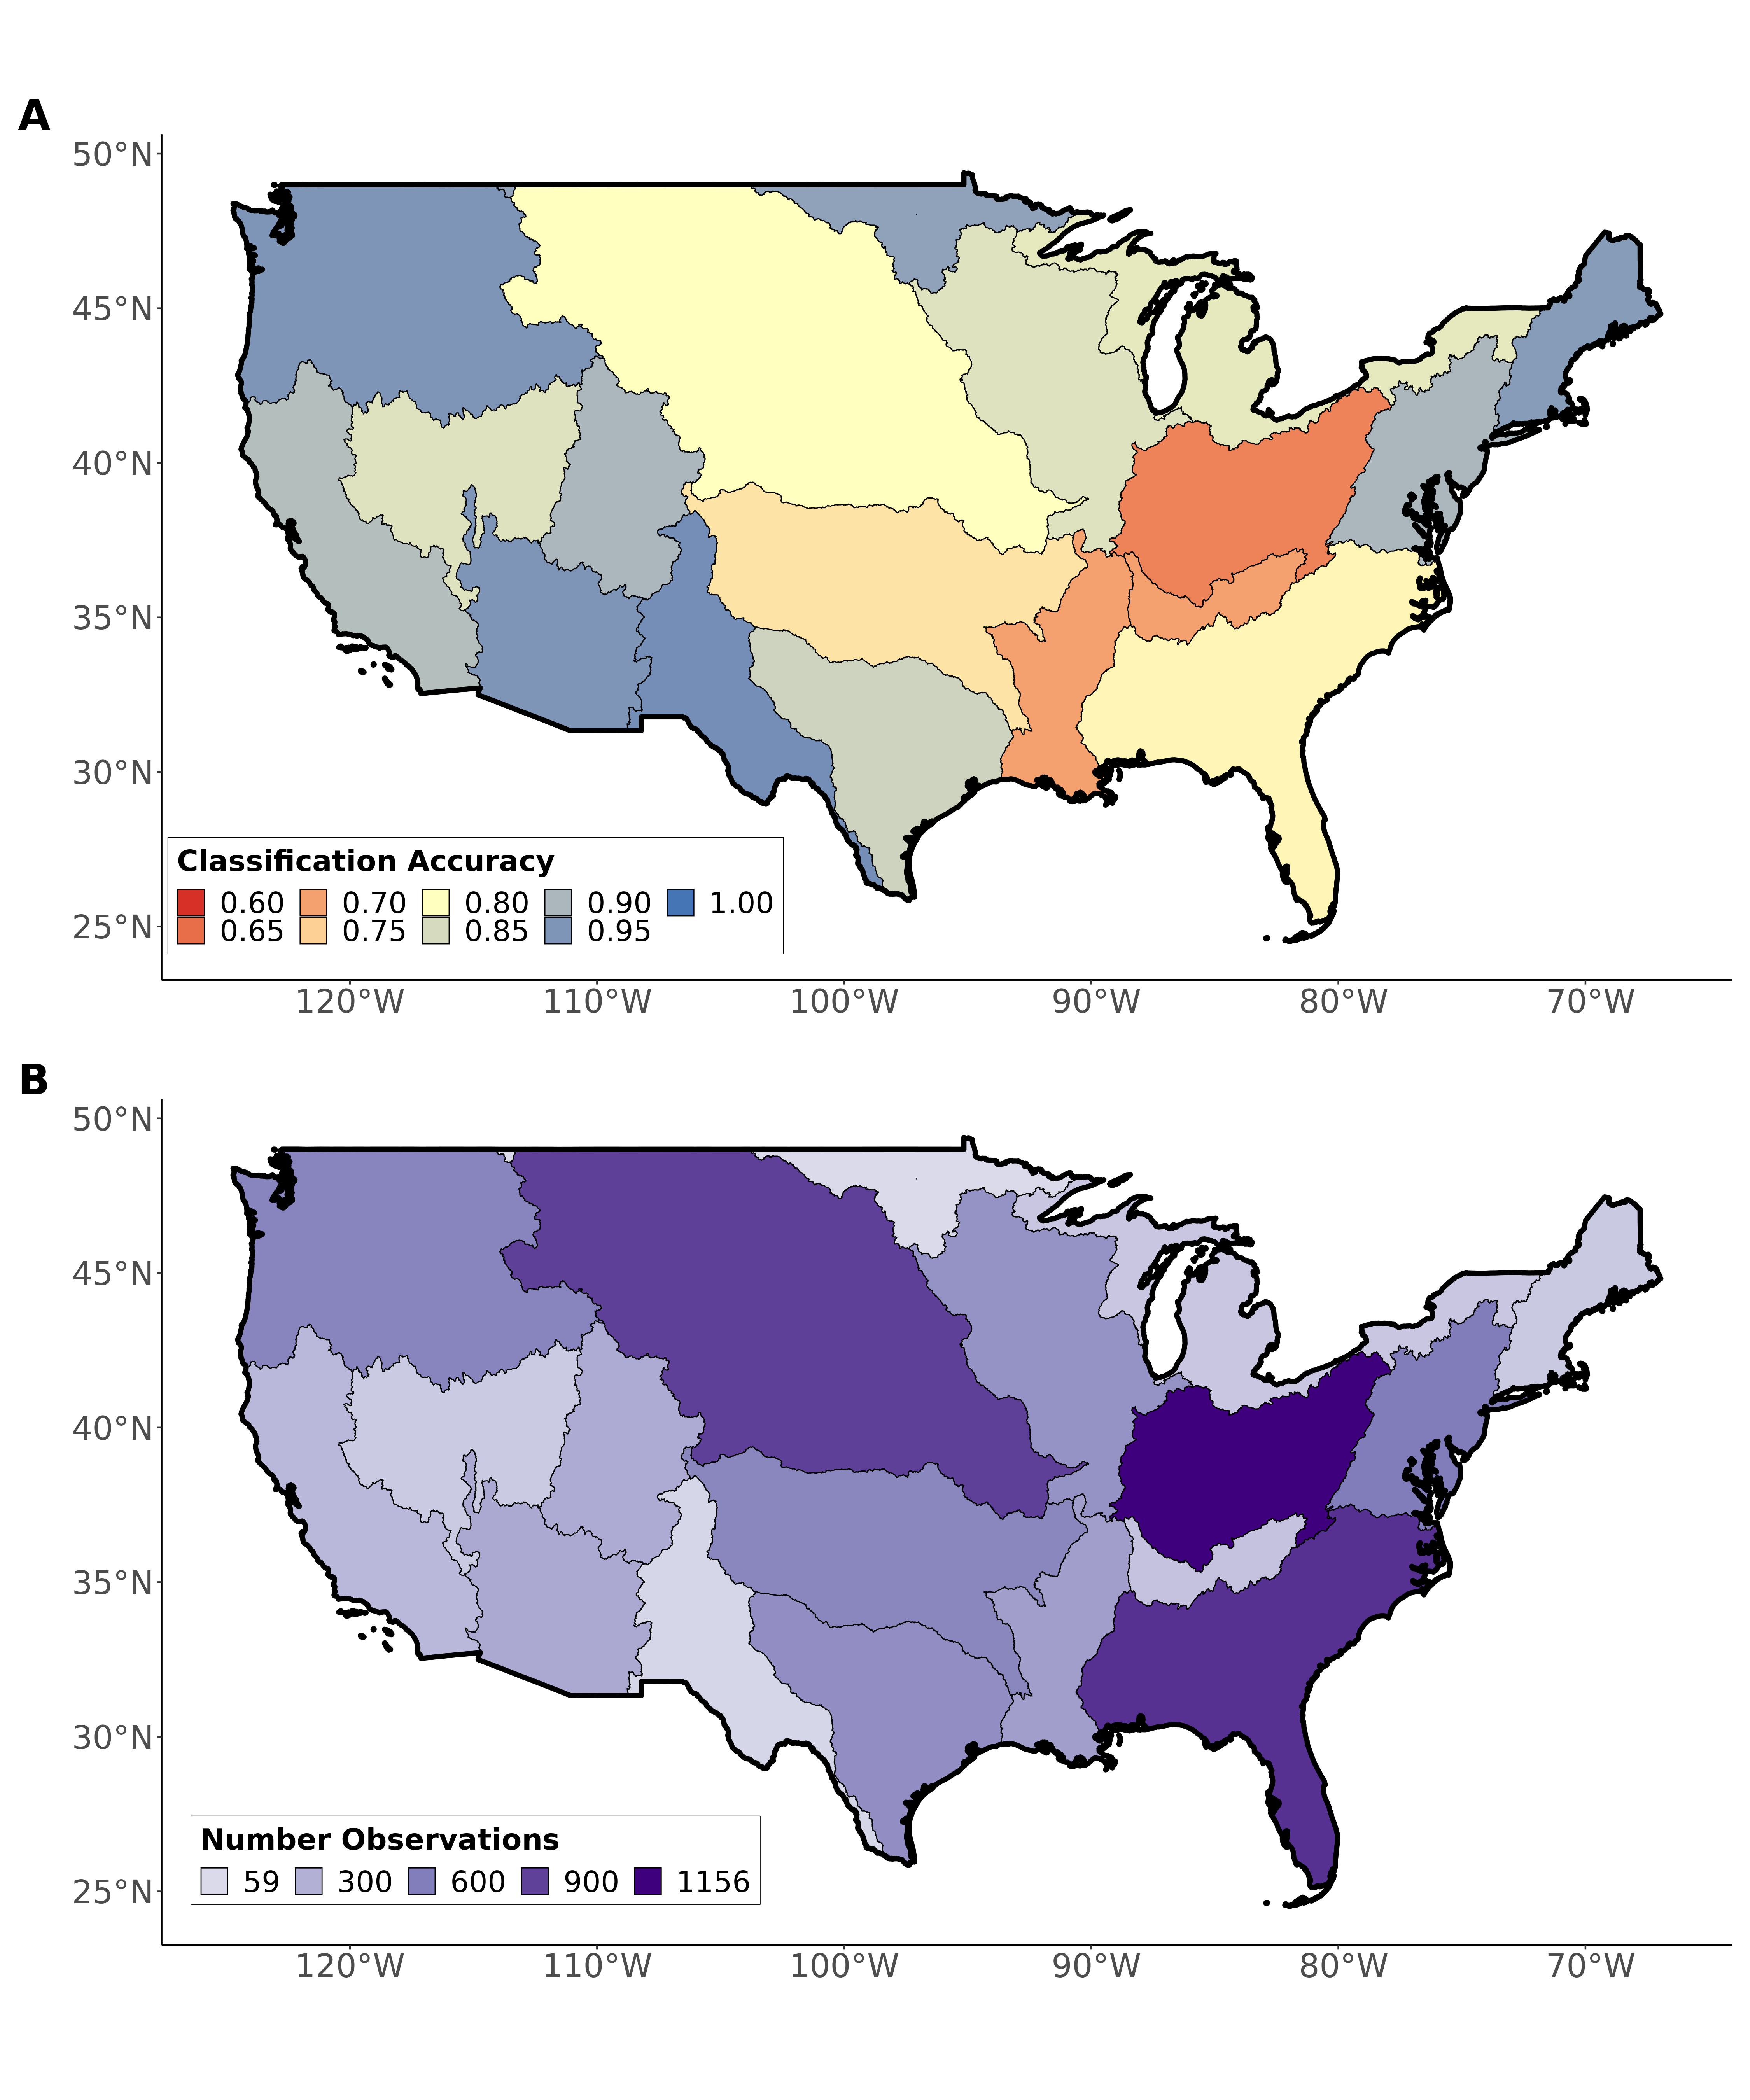

Fig. S1: Regional validations of the ephemeral stream classification model against completely independent field assessments of stream ephemerality: (A) regional model classification accuracy and (B) number of field-observations. The average regional classification accuracy is 85% and the average number of regional observations is 438. Consult the supplemental materials for more on how we validate the model (including additional performance metrics).

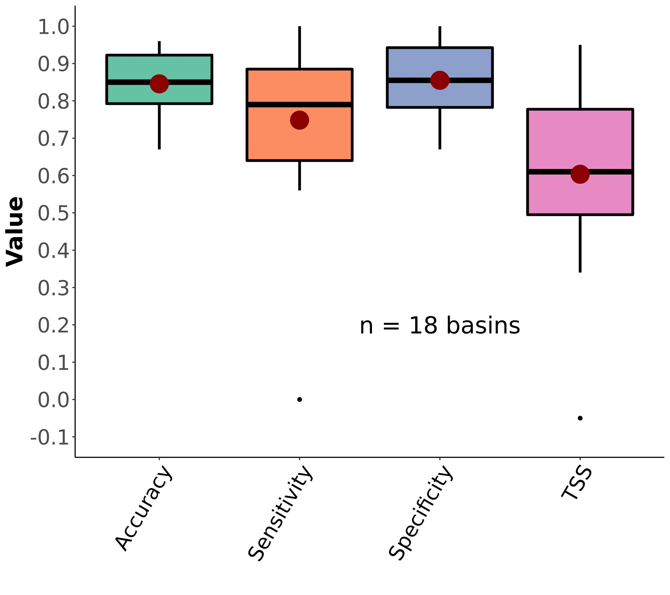

Fig. S2: Boxplots of regional ephemeral classification performance, by accuracy metric (section 3). Red dots correspond to the mean value. The ovbious outlier scores for sensitivity and TSS are from region HUC09 (Minnesota and Wisconsin draining to Canada) and due to there only being 1 ephemeral assessment in our dataset in that region. See Table S2 for metric definitions.

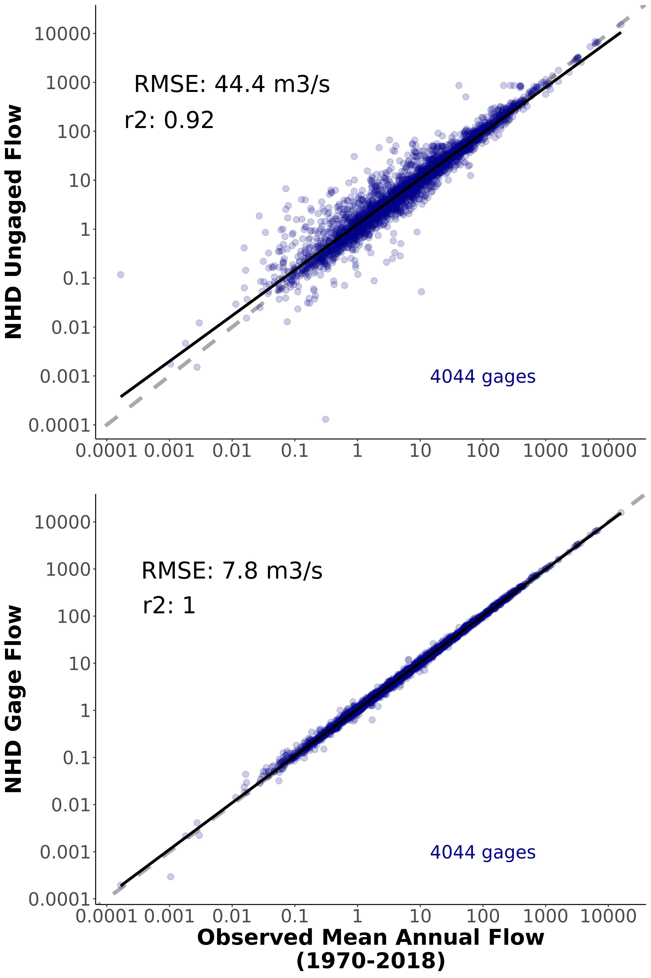

Fig. S3: Validation of discharge model at 4,044 streamgauges across CONUS. a) Ungauged validation, using the ‘unadjusted’ model discharges. These are reflective of model performance in unaguged streams and represent the vast majority of the network. b) Gauged validation, using the model discharges after adjustment to the streamgauge. These represent the errors in the gauged reaches in the network.

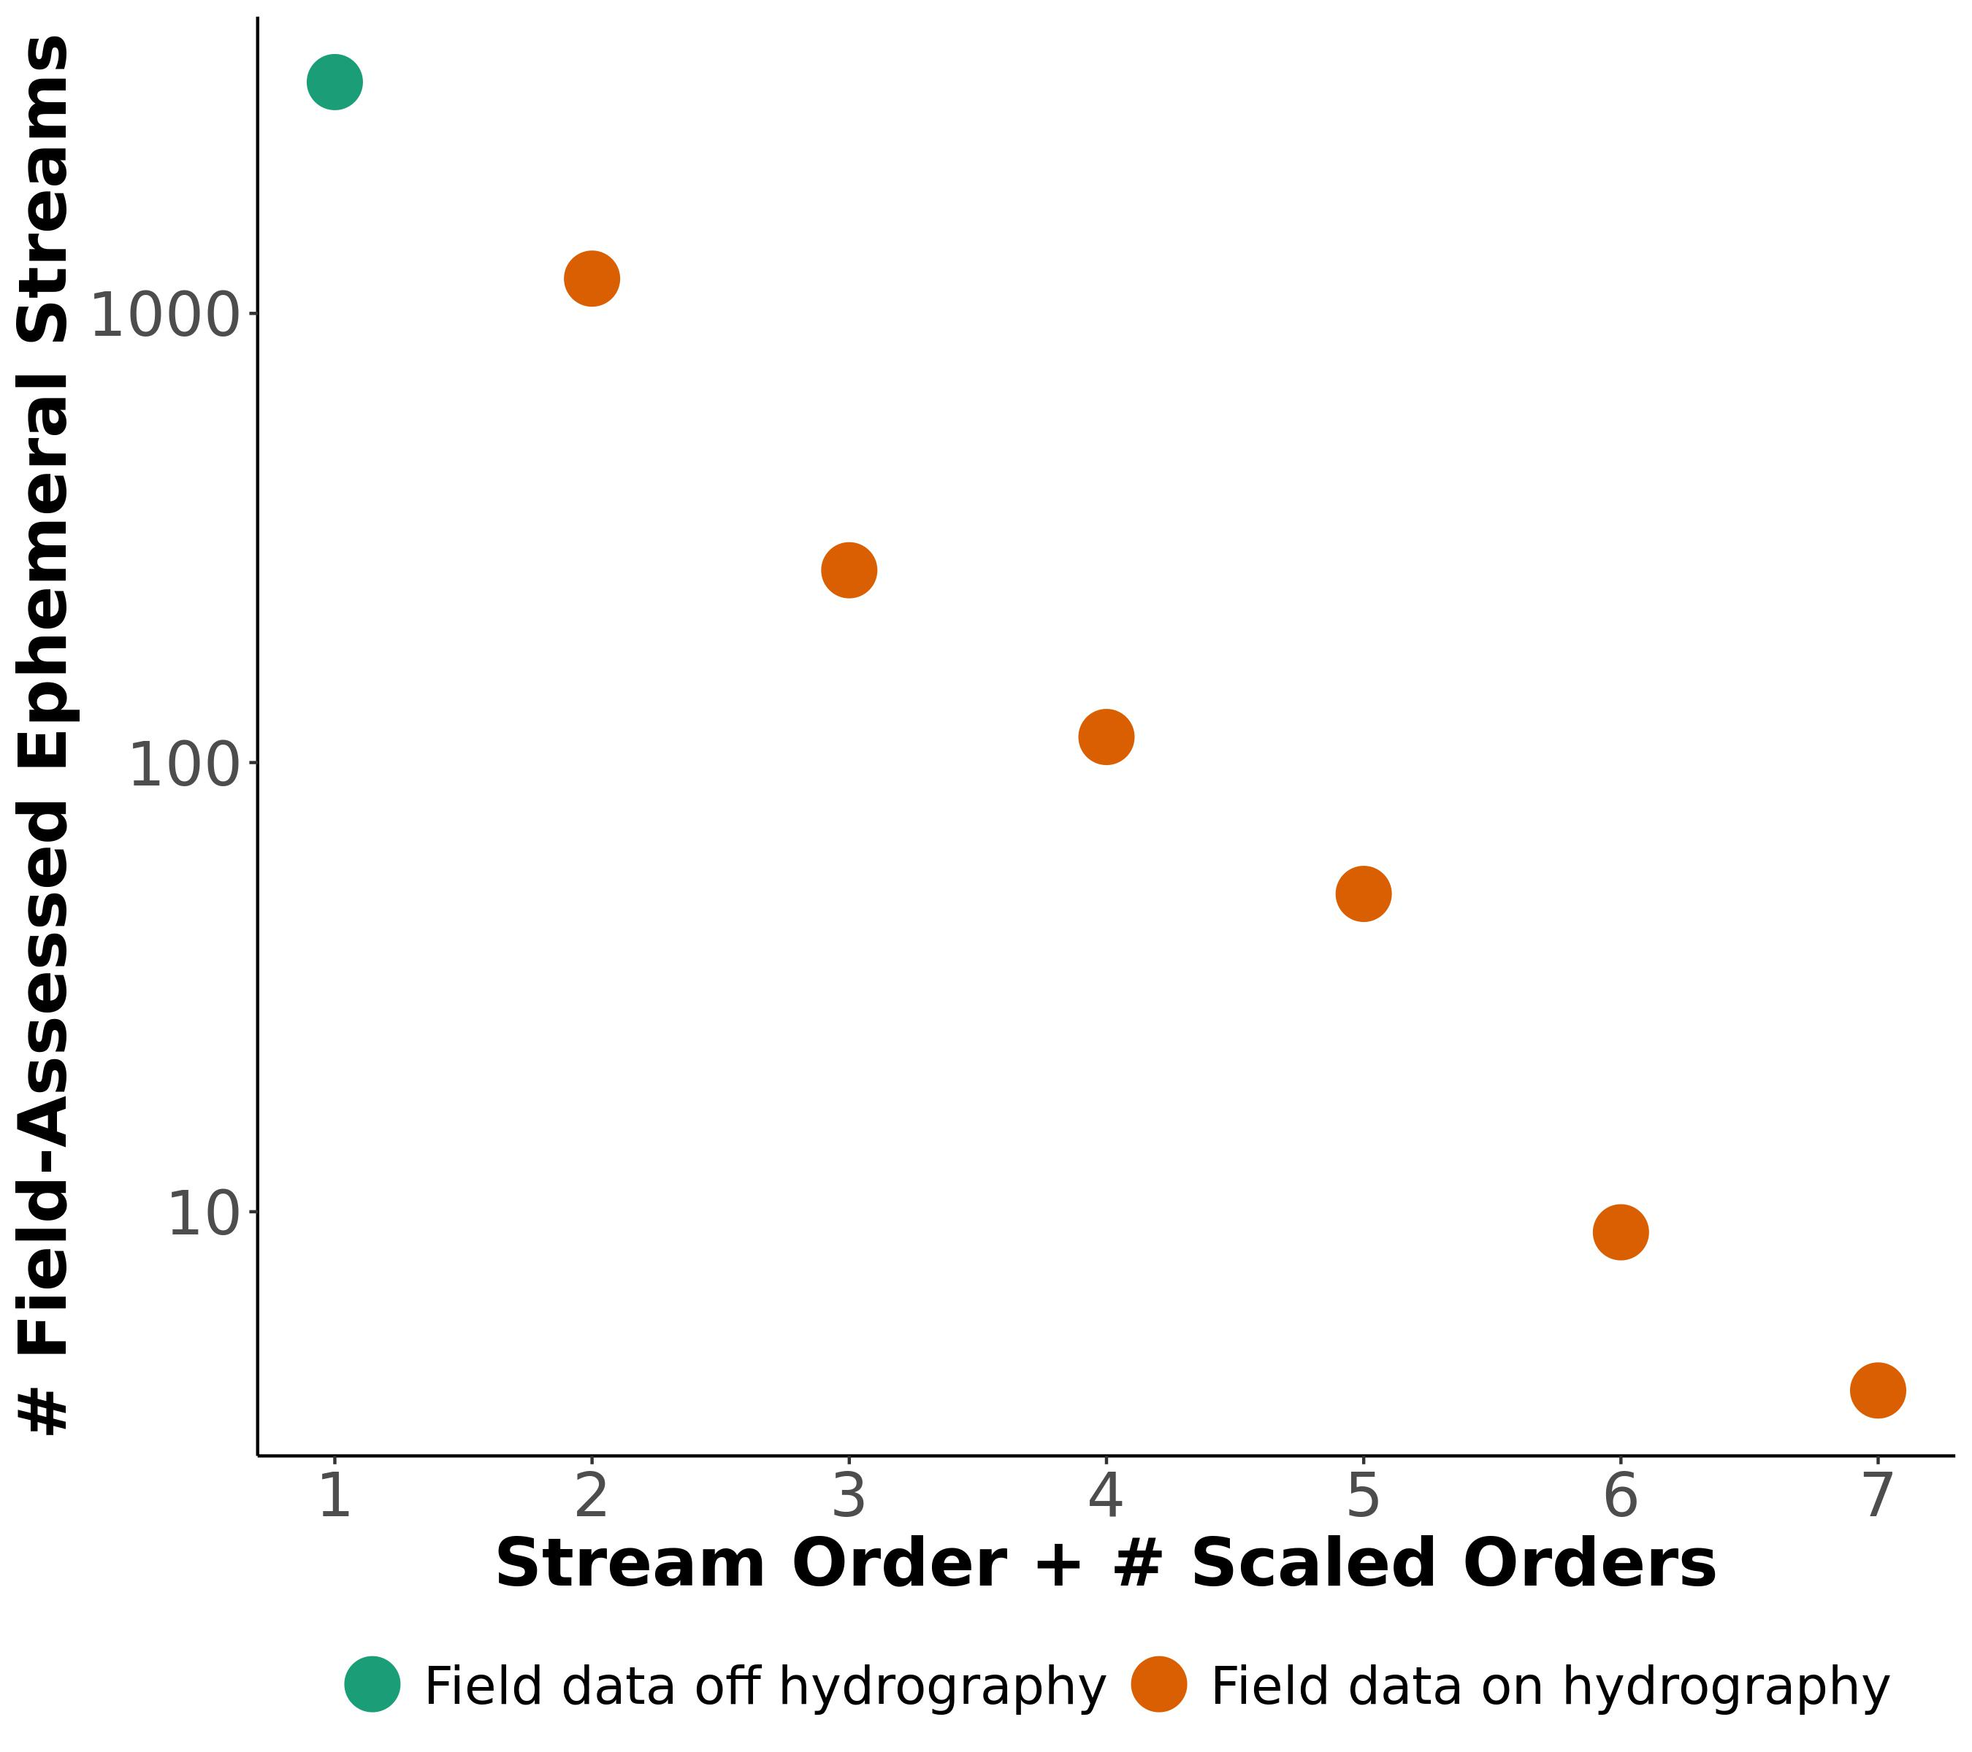

Fig. S4: Ephemeral scaling model for CONUS ephemeral stream network beyond our hydrography framework. Orange points are associated with reaches while the green point is the number of ephemeral streams not associated with reaches. 1 additional order is needed to ‘capture’ the green point and match this observed pattern in our data (Section 3).

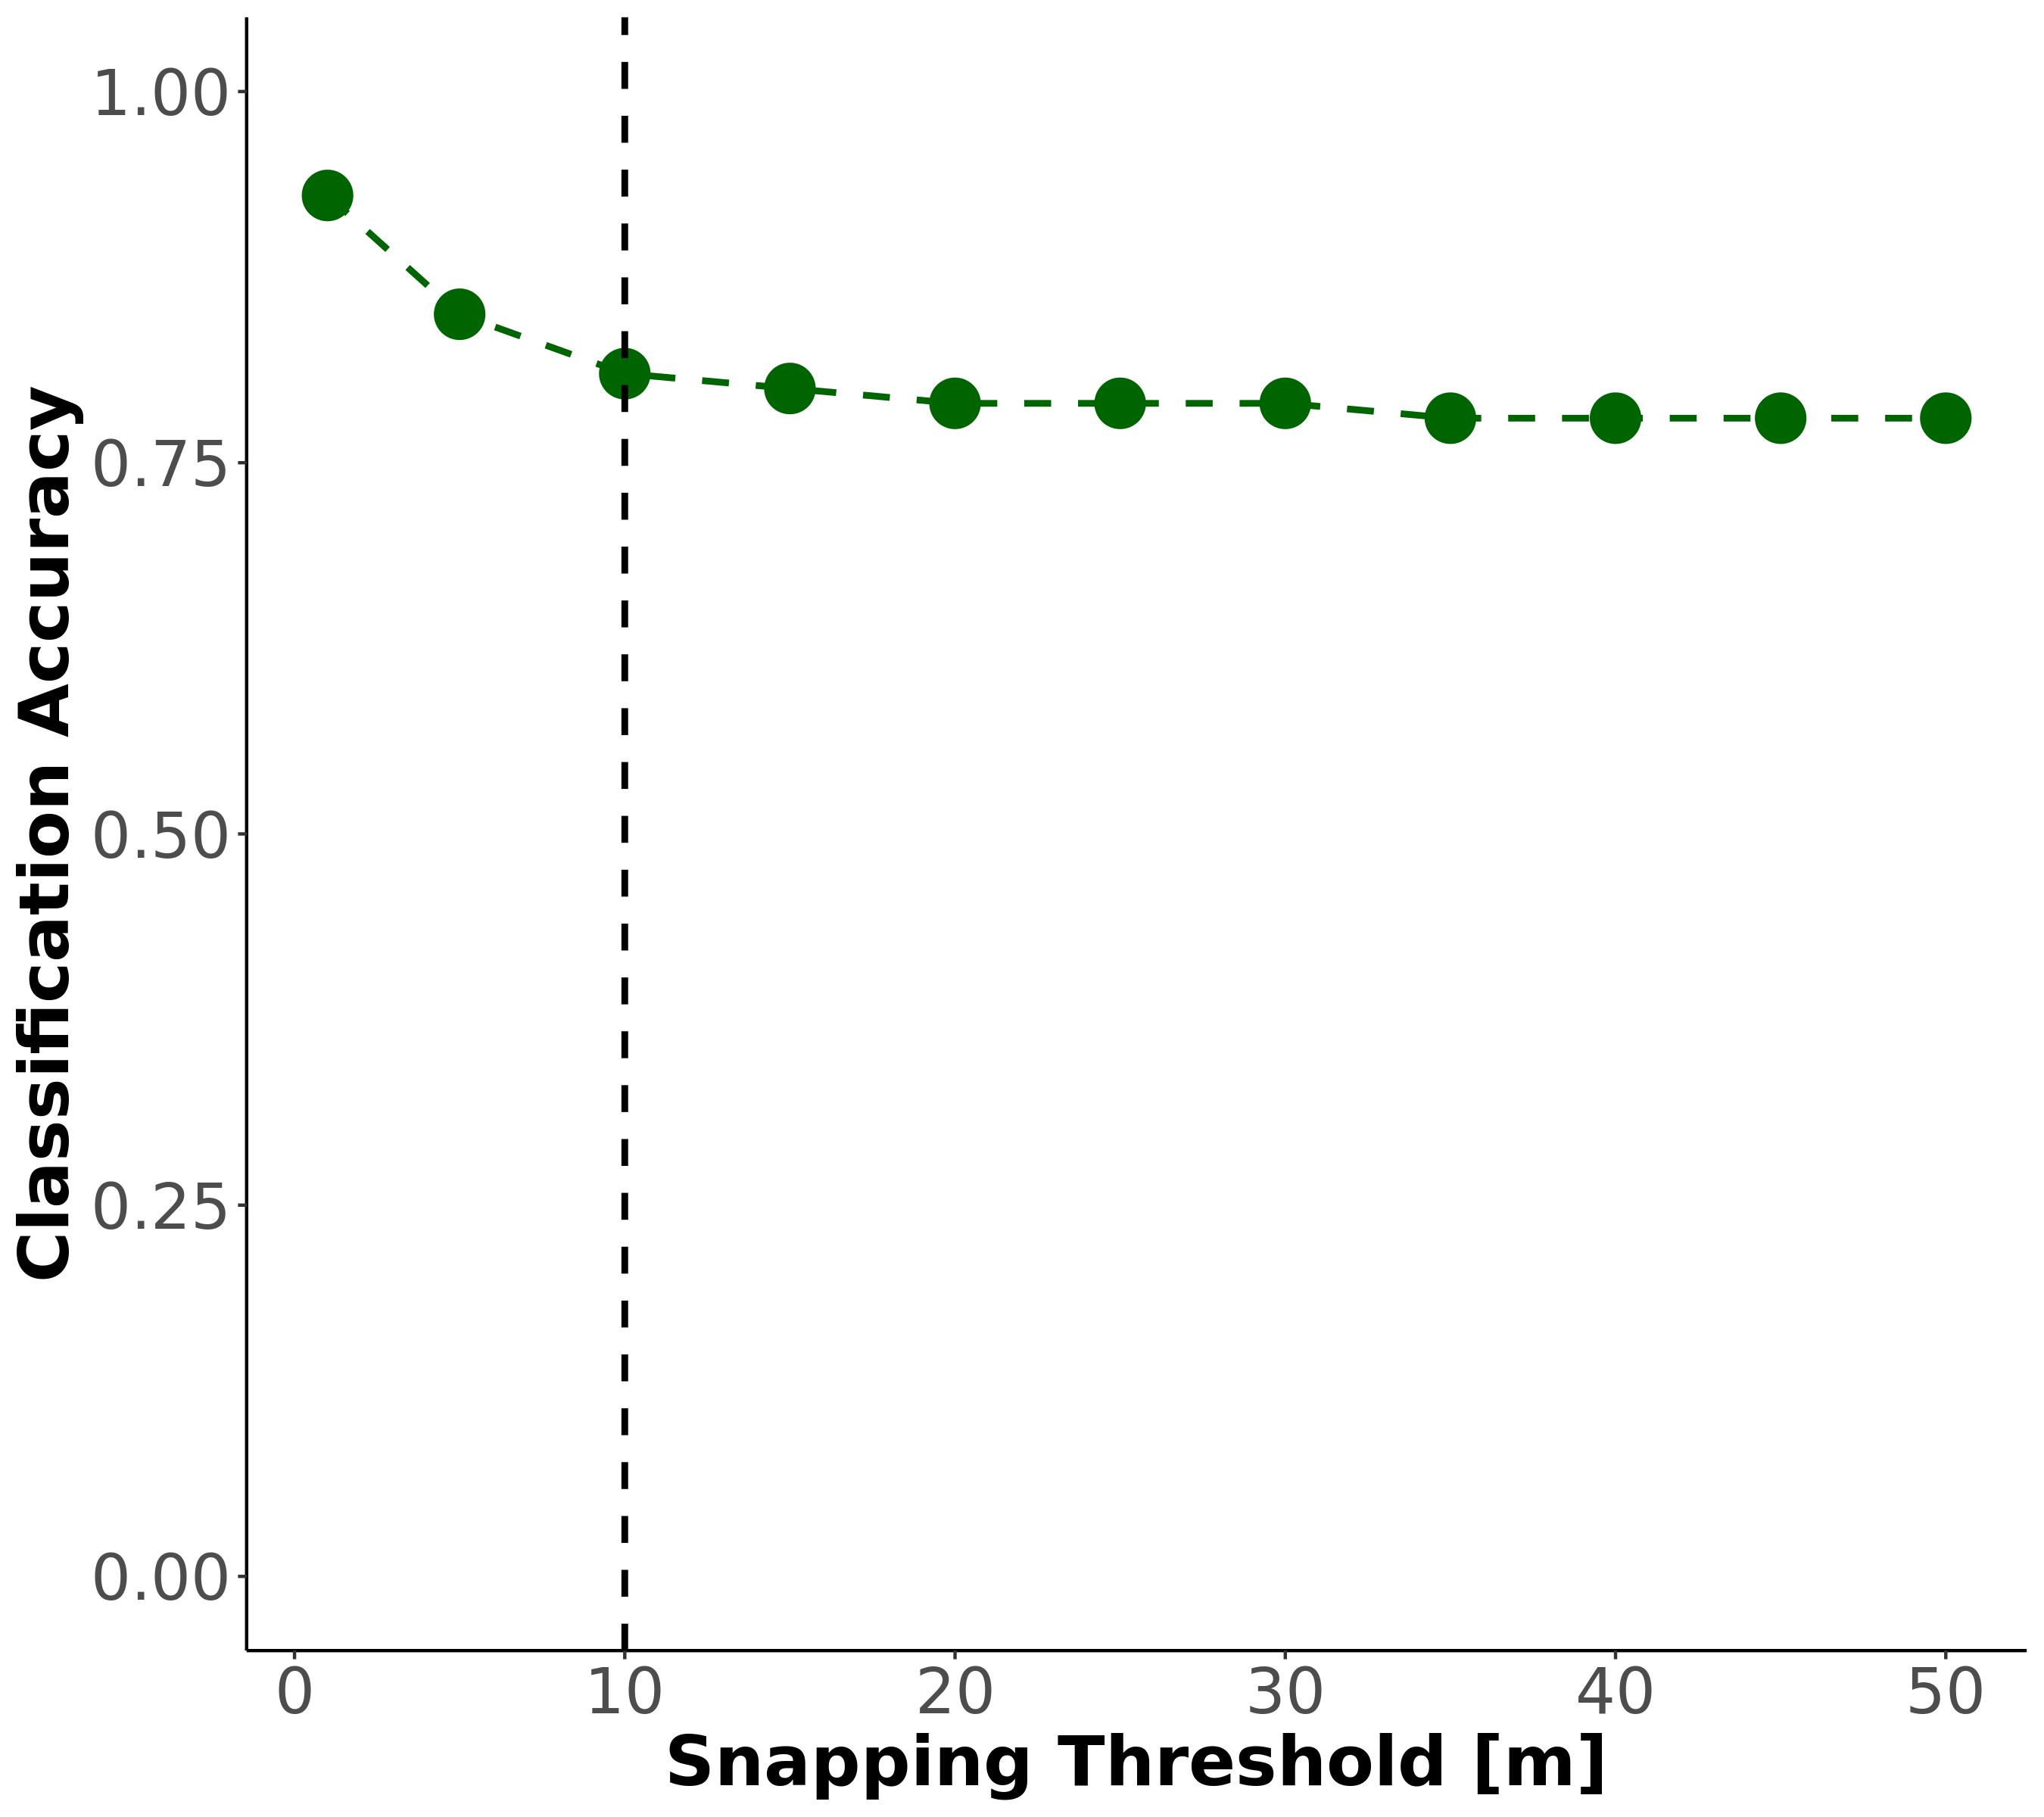

Fig. S5: CONUS-wide classification sensitivity to snapping threshold. Note that the regional accuracy reported in Figs. S1 and are more useful from a model performance perspective, but here we are simply confirming that model accuracy is not significantly influenced by snapping threshold. Our chosen 10m threshold is noted by the dashed line.

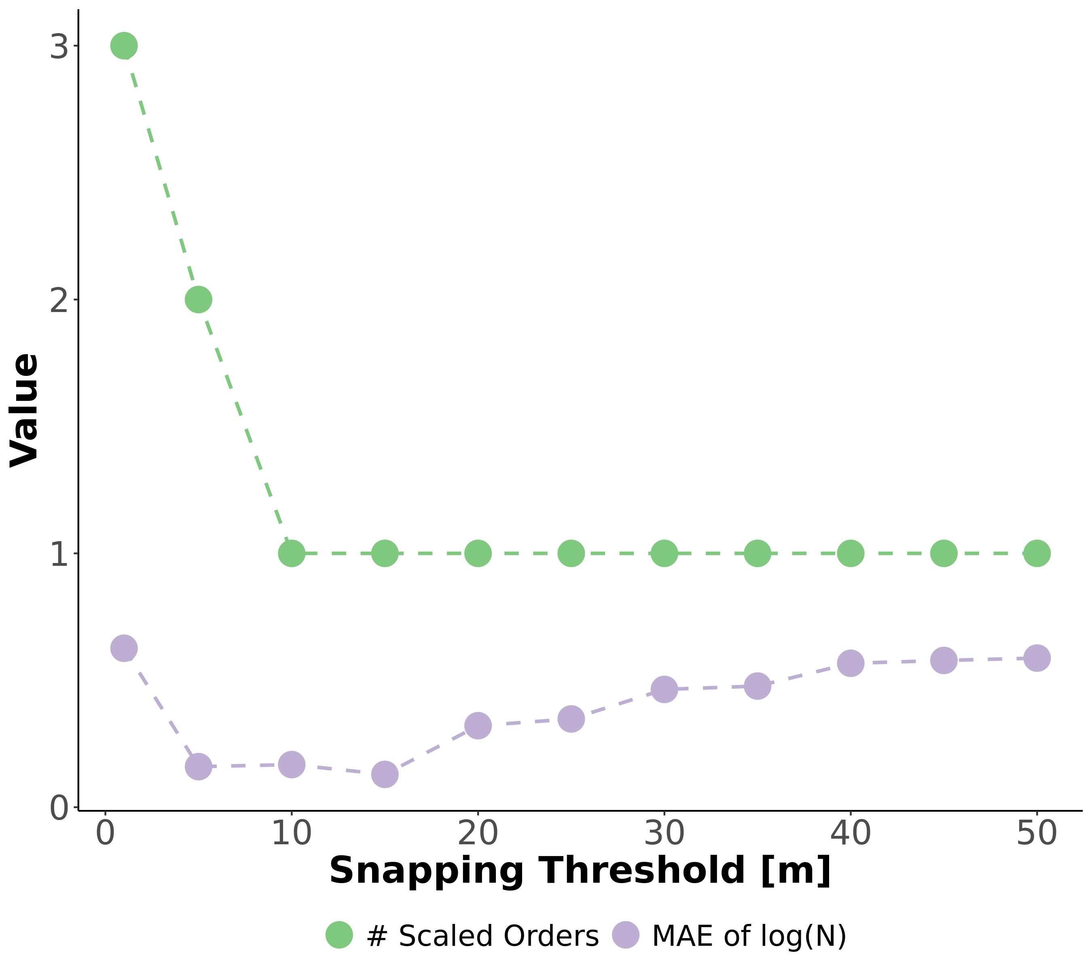

Fig. S6: Sensitivity test of the snapping threshold used to join field assessments of ephemerality (section 2) to the drainage network. Green line is the number of additional stream orders calculated by equation S9, given a snapping threshold. Purple line is the mean absolute error (MAE) of the Horton law of stream numbers (equation S4), given a snapping threshold. MAE should be smallest when the data best fit Horton’s laws, indicating that we are not missassinging field data to the wrong rivers. This is explained in detail in section 2.

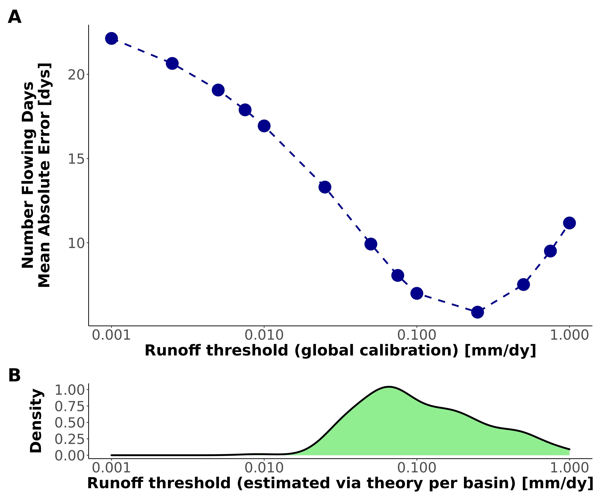

Fig. S7: Assessing the robustness of our runoff threshold ($i_{min}$) model (equation S9) by comparing it against a calibrated $i_{min}$ (section 6.2). (A): Global-scope calibration of $i_{min}$ to available $N_{flw}$ data (section 6.1).(B): Distribution of by-basin $i_{min}$ as calculated using equation S9. This model is the one used to generate the Fig. 2 results.

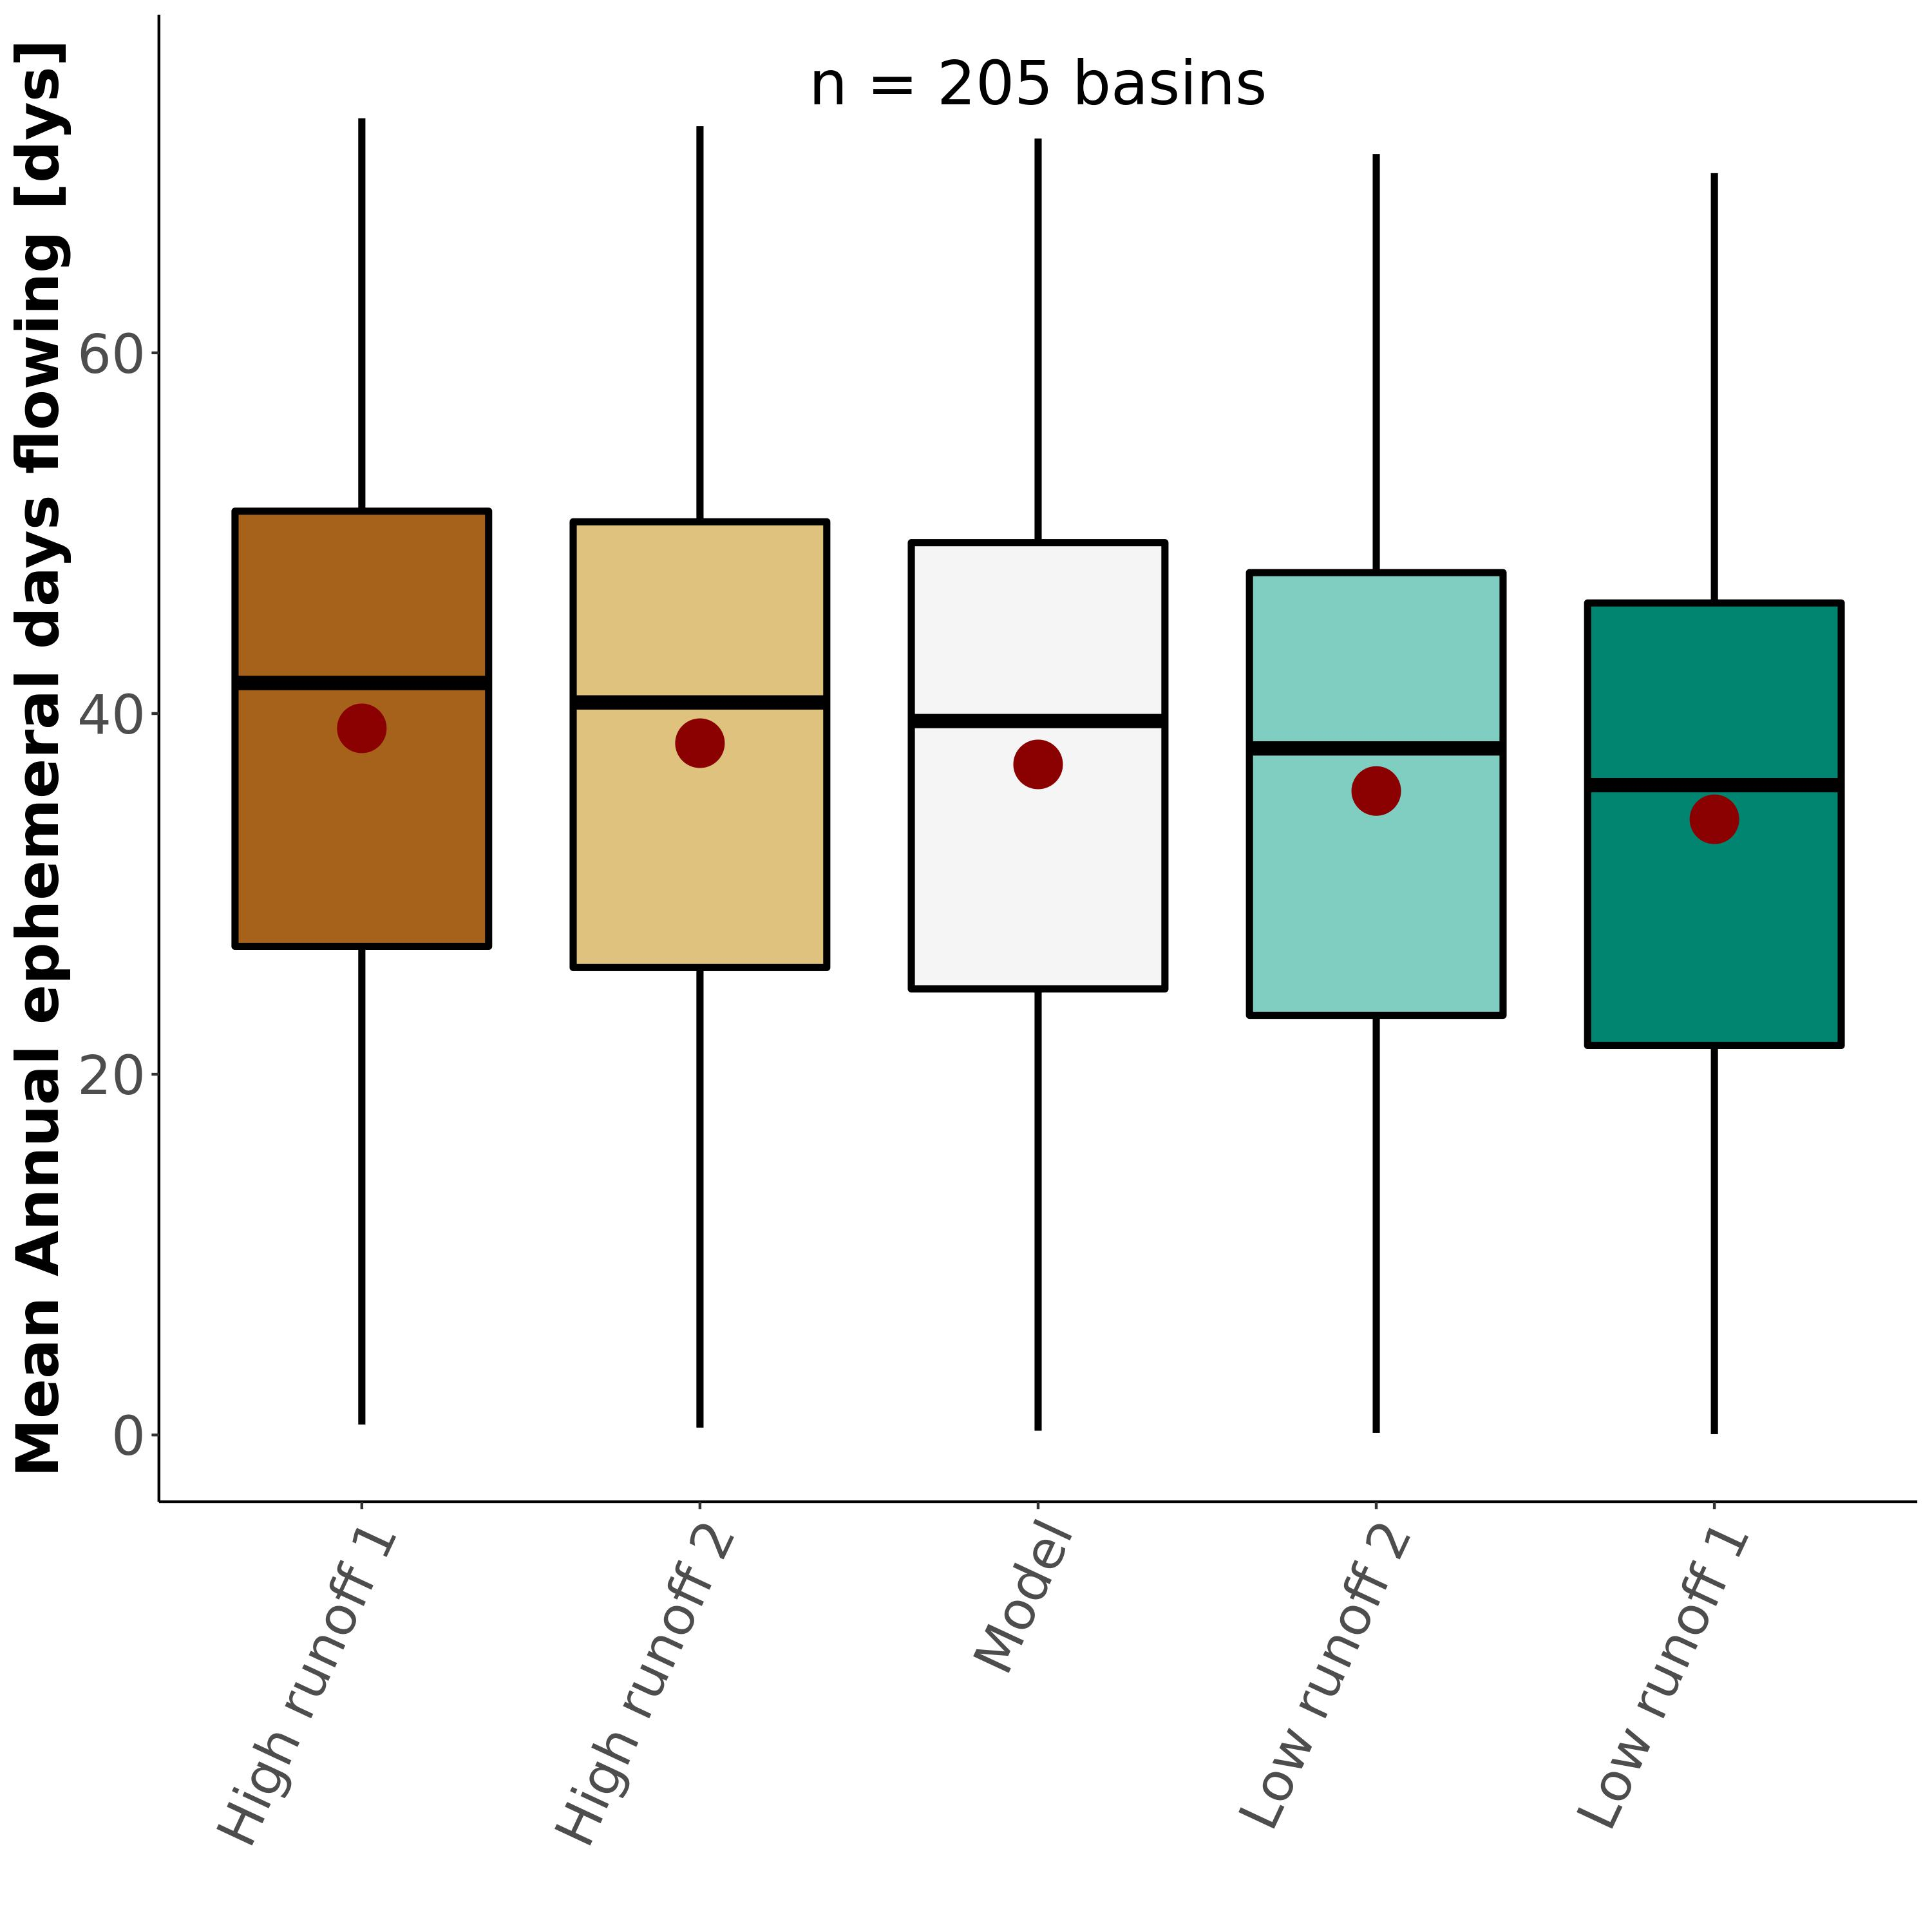

Fig. S8: Sensitivity test for the $N_{flw}$ calculation, resulting in boxplots of the basin-averaged, mean annual number of days that ephemeral streams flow (equivalent to Fig. 2a). Table S4 details the runoff scenarios used.

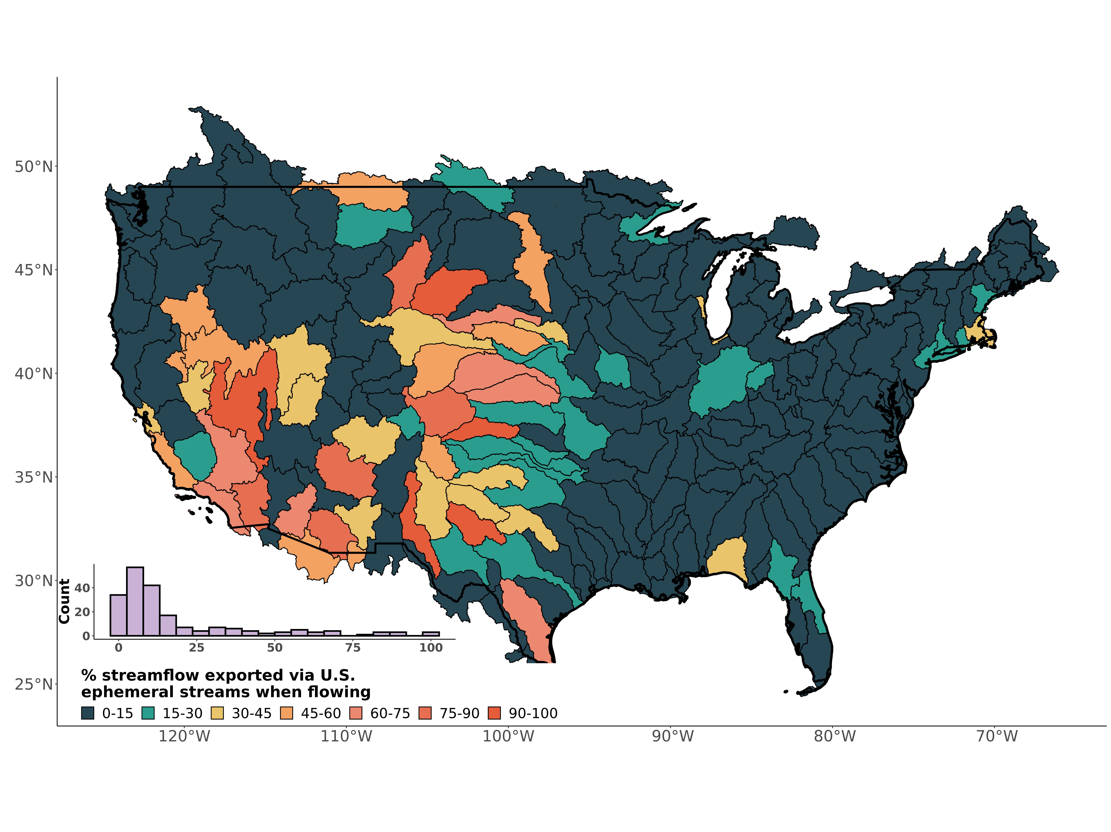

Fig. S9: Contiguous United States map and distribution of the ephemeral contribution to streamflow if all ephemeral streams were simultaneously flowing, via equation S4.

## Supplementary Tables

**Table S1** Field assessments of stream ephemerality performed in New England, Summer 2022. We followed the ephemeral/intermittent/perennial protocol for the State of North Carolina Department of Water Quality (*26*). Scores < 19 are deemed ‘ephemeral’.

| Name | Latitude | Longitude | Score | Classification |
| --- | --- | --- | --- | --- |
| Tucker1 | 42.95125 | -71.07311 | 5.5 | ephemeral |
| Tucker2 | 42.94875 | -71.07479 | 15.0 | ephemeral |
| Atkins1 | 42.41396 | -72.46797 | 16.5 | ephemeral |
| Atkins2 | 42.42449 | -72.48076 | 8.0 | ephemeral |
| Harkness1 | 42.36701 | -72.47190 | 12.5 | ephemeral |

**Table S2:** Classification metrics used to assess the ephemeral mapping model. *TP* is the true positive rate, *TN* is the true negative rate, *FP* is the false positive rate, and *FN* is the false negative rate.

| Name | Definition |
| --- | --- |
| Accuracy | $\frac{N_{TP}+N_{TN}}{N_{TP}+N_{TN}+N_{FP}+N_{FN}}$ |
| Sensitivity | $\frac{N_{TP}}{N_{TP}+N_{FN}}$ |
| Specificity | $\frac{N_{TN}}{N_{TN}+N_{FP}}$ |
| True Skill Score (TSS) | Sensitivity + Specificity - 1 |

**Table S3:** Mean annual number of flowing days for ephemeral streams per basin compared against the same value calculated via our model. Note that basins with multiple watersheds were averaged to compare against our basin model in Fig. 2b.

|  | Model Basin | Model Nflw [dys] | Watershed | Observed Nflw [dys] | Reference |
| --- | --- | --- | --- | --- | --- |
| 33 | Neuse-Pamlico | 46 | Duke Forest | 59 | Zimmer & McGlynn, 2017 |
| 60 | Lake Ontario and Niagara Peninsula | 47 | Guelph | 57 | Peirce & Lindsay, 2015 |
| 187 | Lower Gila | 5 | Goldwater | 1 | Stromberg et al. 2017 |
| 190 | Middle Gila | 8 | Huachuca | 2 | Stromberg et al. 2017 |
| 188 | Lower Colorado | 13 | Mohave-Yuma | 2 | Kampf et al. 2018 |
| 177 | Rio Grande-Elephant Butte | 14 | Montoyas | 1 | Schoener 2022 |
| 201 | Middle Snake | 41 | Reynolds Creek | 28 | Slaughter et al. 2001 |
| 78 | Kentucky-Licking | 55 | Robinson Forest | 50 | Fritz et al. 2019 |
| 190.1 | Middle Gila | 8 | Santa Rita | 10 | Moran et al. 2008 |
| 190.2 | Middle Gila | 8 | Walnut Gulch | 7 | Moran et al. 2008 |

**Table S4:** Runoff scenarios used in the $N_{flw}$ sensitivity analysis. See section 6.2 for more specifics.

| Name | Runoff Memory | Runoff ratio ($i_{r}$) |
| --- | --- | --- |
| Low runoff 1 | 10 days | $i_{r}+0.33i_{r}$ |
| Low runoff 2 | 6 days | $i_{r}+0.18i_{r}$ |
| High runoff 1 | 0 days | $i_{r}−0.33i_{r}$ |
| High runoff 2 | 1 day | $i_{r}+0.18i_{r}$ |

## References

1. Department of the Army, Corps of Engineers, E. P. Agency, The Navigable Waters Protection Rule: Definition of “Waters of the United States.” *Federal Register* (2020).

2. P. A. Raymond, J. E. Saiers, W. V. Sobczak, [Hydrological and biogeochemical controls on watershed dissolved organic matter transport: Pulse-shunt concept](https://doi.org/10.1890/14-1684.1). *Ecology*. **97**, 5–16 (2016).

3. B. He, S. Kanae, T. Oki, Y. Hirabayashi, Y. Yamashiki, K. Takara, [Assessment of global nitrogen pollution in rivers using an integrated biogeochemical modeling framework](https://doi.org/10.1016/j.watres.2011.02.011). *Water Research*. **45**, 2573–2586 (2011).

4. C. Schmidt, T. Krauth, S. Wagner, [Export of Plastic Debris by Rivers into the Sea](https://doi.org/10.1021/acs.est.7b02368). *Environmental Science & Technology*. **51**, 12246–12253 (2017).

5. M. Liu, Q. Zhang, T. Maavara, S. Liu, X. Wang, P. A. Raymond, [Rivers as the largest source of mercury to coastal oceans worldwide](https://doi.org/10.1038/s41561-021-00793-2). *Nature Geoscience*. **14**, 672–677 (2021).

6. D. A. Keiser, J. S. Shapiro, [Consequences of the Clean Water Act and the Demand for Water Quality*](https://doi.org/10.1093/qje/qjy019). *The Quarterly Journal of Economics*. **134**, 349–396 (2019).

7. M. L. Messager, B. Lehner, C. Cockburn, N. Lamouroux, H. Pella, T. Snelder, K. Tockner, T. Trautmann, C. Watt, T. Datry, [Global prevalence of non-perennial rivers and streams](https://doi.org/10.1038/s41586-021-03565-5). *Nature*. **594**, 391–397 (2021).

8. K. L. Jaeger, R. Sando, R. R. McShane, J. B. Dunham, D. P. Hockman-Wert, K. E. Kaiser, K. Hafen, J. C. Risley, K. W. Blasch, [Probability of Streamflow Permanence Model (PROSPER): A spatially continuous model of annual streamflow permanence throughout the Pacific Northwest](https://doi.org/10.1016/j.hydroa.2018.100005). *Journal of Hydrology X*. **2**, 100005 (2019).

9. N. Durighetto, V. Mariotto, F. Zanetti, K. J. McGuire, G. Mendicino, A. Senatore, G. Botter, [Probabilistic Description of Streamflow and Active Length Regimes in Rivers](https://doi.org/10.1029/2021WR031344). *Water Resources Research*. **58**, e2021WR031344 (2022).

10. P. P. Russell, S. M. Gale, B. Muñoz, J. R. Dorney, M. J. Rubino, [A Spatially Explicit Model for Mapping Headwater Streams](https://doi.org/10.1111/jawr.12250). *JAWRA Journal of the American Water Resources Association*. **51**, 226–239 (2015).

11. K. A. Fesenmyer, S. J. Wenger, D. S. Leigh, H. M. Neville, [Large portion of USA streams lose protection with new interpretation of Clean Water Act](https://doi.org/10.1086/713084). *Freshwater Science*. **40**, 252–258 (2021).

12. Materials and methods are available as supplementary materials at the Science website.

13. D. c. Goodrich, W. g. Kepner, L. r. Levick, P. j. Wigington Jr., [Southwestern Intermittent and Ephemeral Stream Connectivity](https://doi.org/10.1111/1752-1688.12636). *JAWRA Journal of the American Water Resources Association*. **54**, 400–422 (2018).

14. B. R. Scanlon, C. C. Faunt, L. Longuevergne, R. C. Reedy, W. M. Alley, V. L. McGuire, P. B. McMahon, [Groundwater depletion and sustainability of irrigation in the US High Plains and Central Valley](https://doi.org/10.1073/pnas.1200311109). *Proceedings of the National Academy of Sciences*. **109**, 9320–9325 (2012).

15. Y. Fan, G. Miguez-Macho, E. G. Jobbágy, R. B. Jackson, C. Otero-Casal, [Hydrologic regulation of plant rooting depth](https://doi.org/10.1073/pnas.1712381114). *Proceedings of the National Academy of Sciences*. **114**, 10572–10577 (2017).

16. U. S. G. Survey, National Hydrography Dataset (ver. USGS National Hydrography Dataset High Resolution(NHD-HR) for Hydrologic Unit (HU) 4 (2022).

17. B. B. Cael, A. J. Heathcote, D. A. Seekell, [The volume and mean depth of Earth’s lakes](https://doi.org/10.1002/2016GL071378). *Geophysical Research Letters*. **44**, 209–218 (2017).

18. C. B. Brinkerhoff, C. J. Gleason, C. J. Zappa, P. A. Raymond, M. E. Harlan, [Remotely sensing river greenhouse gas exchange velocity using the SWOT satellite](https://doi.org/10.1029/2022GB007419). *Global Biogeochemical Cycles*. **n/a**, e2022GB007419.

19. R. E. Horton, [EROSIONAL DEVELOPMENT OF STREAMS AND THEIR DRAINAGE BASINS; HYDROPHYSICAL APPROACH TO QUANTITATIVE MORPHOLOGY](https://doi.org/10.1130/0016-7606(1945)56[275:EDOSAT]2.0.CO;2). *GSA Bulletin*. **56**, 275–370 (1945).

20. J. w. Brakebill, D. m. Wolock, S. e. Terziotti, [Digital Hydrologic Networks Supporting Applications Related to Spatially Referenced Regression Modeling1](https://doi.org/10.1111/j.1752-1688.2011.00578.x). *JAWRA Journal of the American Water Resources Association*. **47**, 916–932 (2011).

21. P. Xie, M. Chen, S. Yang, A. Yatagai, T. Hayasaka, Y. Fukushima, C. Liu, [A Gauge-Based Analysis of Daily Precipitation over East Asia](https://doi.org/10.1175/JHM583.1). *Journal of Hydrometeorology*. **8**, 607–626 (2007).

22. G. H. Allen, T. M. Pavelsky, E. A. Barefoot, M. P. Lamb, D. Butman, A. Tashie, C. J. Gleason, [Similarity of stream width distributions across headwater systems](https://doi.org/10.1038/s41467-018-02991-w). *Nature Communications*. **9**, 610 (2018).

23. J. Dewitz, National Land Cover Database (NLCD) 2019 Products (2021), doi:[10.5066/P9KZCM54](https://doi.org/10.5066/P9KZCM54).

24. C. B. Brinkerhoff, P. A. Raymond, T. Maavara, Y. Ishitsuka, K. S. Aho, C. J. Gleason, [Lake Morphometry and River Network Controls on Evasion of Terrestrially Sourced Headwater CO2](https://doi.org/10.1029/2020GL090068). *Geophysical Research Letters*. **48**, e2020GL090068 (2021).

25. USEPA, CWA Approved JDs.

26. J. Dorney, P. Russell, "[Chapter 4.1.1 - North Carolina Division of Water Quality Methodology for Identification of Intermittent and Perennial Streams and Their Origins](https://doi.org/10.1016/B978-0-12-805091-0.00014-1)" in *Wetland and Stream Rapid Assessments*, J. Dorney, R. Savage, R. W. Tiner, P. Adamus, Eds. (Academic Press, 2018), pp. 273–279.

27. Y. Fan, H. Li, G. Miguez-Macho, [Global Patterns of Groundwater Table Depth](https://doi.org/10.1126/science.1229881). *Science*. **339**, 940–943 (2013).

28. O. Allouche, A. Tsoar, R. Kadmon, [Assessing the accuracy of species distribution models: Prevalence, kappa and the true skill statistic (TSS)](https://doi.org/10.1111/j.1365-2664.2006.01214.x). *Journal of Applied Ecology*. **43**, 1223–1232 (2006).

29. J. W. Kirchner, [Statistical inevitability of Horton’s laws and the apparent randomness of stream channel networks](https://doi.org/10.1130/0091-7613(1993)021<0591:SIOHSL>2.3.CO;2). *Geology*. **21**, 591–594 (1993).

30. M. A. Zimmer, B. L. McGlynn, [Bidirectional streamgroundwater flow in response to ephemeral and intermittent streamflow and groundwater seasonality](https://doi.org/10.1002/hyp.11301). *Hydrological Processes*. **31**, 3871–3880 (2017).

31. K. M. Fritz, G. J. Pond, B. R. Johnson, C. D. Barton, [Coarse particulate organic matter dynamics in ephemeral tributaries of a Central Appalachian stream network](https://doi.org/10.1002/ecs2.2654). *Ecosphere*. **10**, e02654 (2019).

32. S. K. Kampf, J. Faulconer, J. R. Shaw, M. Lefsky, J. W. Wagenbrenner, D. J. Cooper, [Rainfall Thresholds for Flow Generation in Desert Ephemeral Streams](https://doi.org/10.1029/2018WR023714). *Water Resources Research*. **54**, 9935–9950 (2018).

33. C. W. Slaughter, D. Marks, G. N. Flerchinger, S. S. Van Vactor, M. Burgess, [Thirty-five years of research data collection at the Reynolds Creek Experimental Watershed, Idaho, United States](https://doi.org/10.1029/2001WR000413). *Water Resources Research*. **37**, 2819–2823 (2001).

34. M. S. Moran, C. D. Holifield Collins, D. C. Goodrich, J. Qi, D. T. Shannon, A. Olsson, Long-term remote sensing database, Walnut Gulch Experimental Watershed, Arizona, United States. *Water Resources Research*. **44** (2008), doi:[10.1029/2006WR005689](https://doi.org/10.1029/2006WR005689).

35. G. Schoener, [Impact of urbanization and stormwater infrastructure on ephemeral channel transmission loss in a semiarid watershed](https://doi.org/10.1016/j.ejrh.2022.101089). *Journal of Hydrology: Regional Studies*. **41**, 101089 (2022).

36. J. C. Stromberg, D. L. Setaro, E. L. Gallo, K. A. Lohse, T. Meixner, [Riparian vegetation of ephemeral streams](https://doi.org/10.1016/j.jaridenv.2016.12.004). *Journal of Arid Environments*. **138**, 27–37 (2017).

37. S. E. Peirce, J. B. Lindsay, [Characterizing ephemeral streams in a southern Ontario watershed using electrical resistance sensors](https://doi.org/10.1002/hyp.10136). *Hydrological Processes*. **29**, 103–111 (2015).

38. K. M. Fritz, S. Fulton, B. R. Johnson, C. D. Barton, J. D. Jack, D. A. Word, R. A. Burke, [Structural and functional characteristics of natural and constructed channels draining a reclaimed mountaintop removal and valley fill coal mine](https://doi.org/10.1899/09-060.1). *Journal of the North American Benthological Society*. **29**, 673–689 (2010).

39. E. Moges, B. L. Ruddell, L. Zhang, J. M. Driscoll, L. G. Larsen, [Strength and Memory of Precipitation’s Control Over Streamflow Across the Conterminous United States](https://doi.org/10.1029/2021WR030186). *Water Resources Research*. **58**, e2021WR030186 (2022).